The Official Publication of ALOA—An International Association of Security Professionals

November 2006

Get to know Pentagon Fo

working for America. i

PLUS!

Greg Perry uses diasgnostics to crack a  
couple of tough gun safes.

RND

Take your business to the next leuel Luith new customer seruice and business man­agement articles.

*&%#**%&&*&*&&*3-jjjija 303* Breck H. Camp CML PO Box 47070 Atlanta GA 30362-0070

liilltllimilliilliiiililllmlliiiliiillliiilmllliiinlill

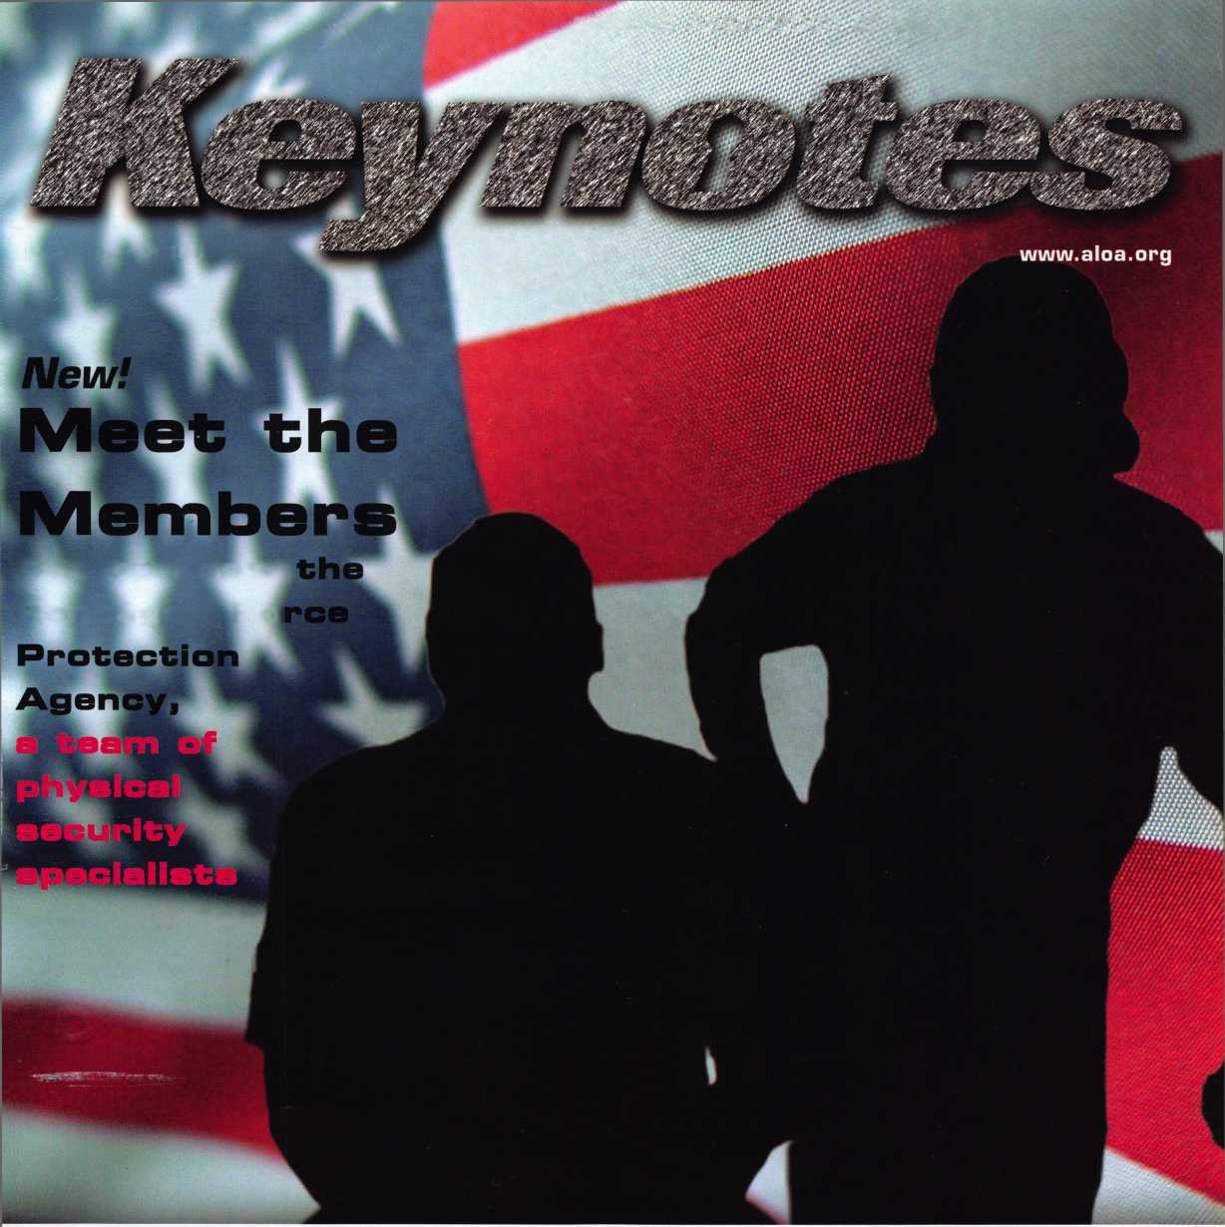

OUR STAND

*L0CKSimTHs*

**Indemnity Company, Northbrook, Ik. Allstate County Mutual Insurance Company, Irving, TX. Allstate New Jersey Insurance feredservice mark and "Our Stand" is a service mark of Allstate Insurance Company. ©2005 Allstate Insurance Company, Northbrook, IL.**

IT’S QUITE POSSIBLY YOUR MOST

TRUSTED SIDEKICK

Keep it in Good Hands® with Allstate.

As a small business owner, there are few things you quick certificates of insurance, ID cards, assistance

rely on more than your vehicle to keep you going. with the claims process, and more. All from one of

Your local Allstate agent can help protect it and the most widely recognized names in the business,

your small business with services you need including **Are you in Good Hands®?**

1-800-859-0247

**CALL NOW TO LOCATE YOUR NEARBY ALLSTATE AGENT.**

/instate

**You’re in good hands.**

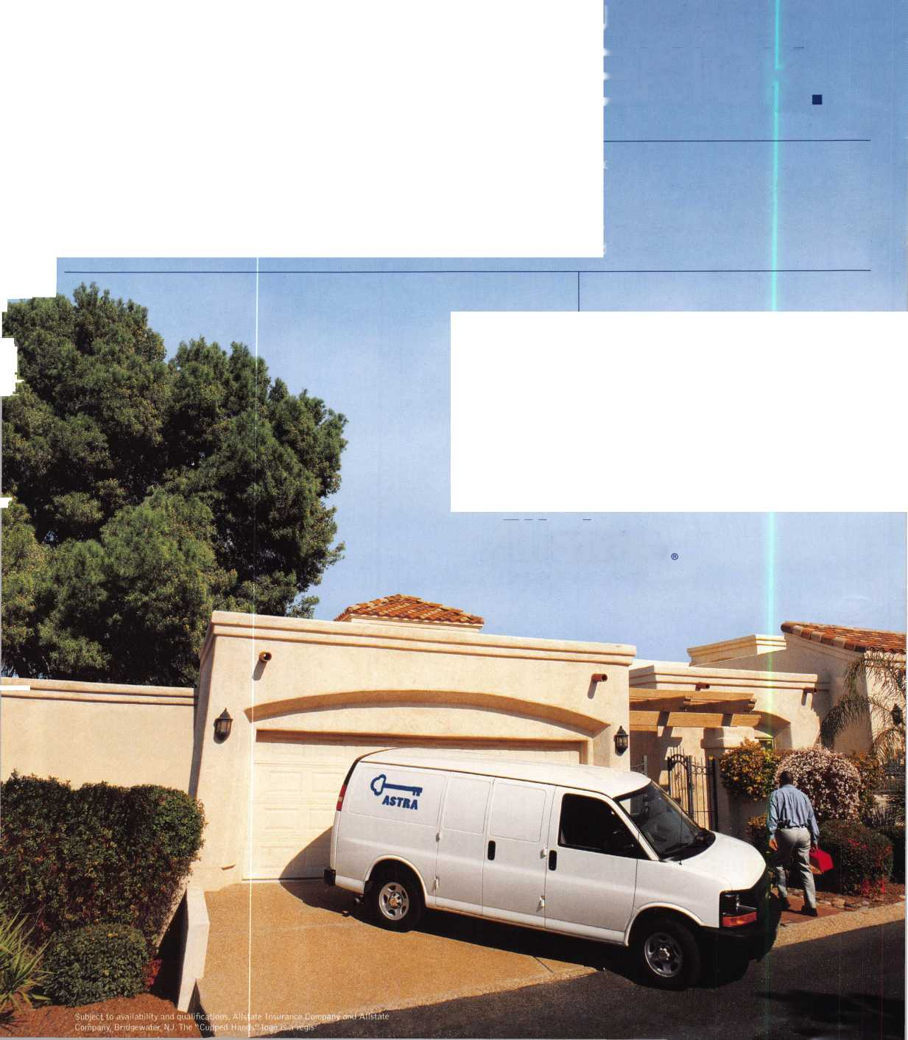

**A Name** You Know

As a business owner, you know the importance of a good name. Your name is your reputation. Your name stands for all that you offer in products and services. It’s a symbol of who you are. So, we thought you might like to know that Allstate, the name you know for insuring your personal vehicle and your home, also offers a business auto policy to help protect vehi­cles used in your locksmith business.

The following are coverages typically included in our business auto policy that might be important to you as a business owner:

Business Auto Liability coverage

* Higher limits up to $2,000,000 per occur­rence.
* Protects you if you are legally responsible for injuries and damages arising out of the ownership, maintenance, or use of business vehicles.
* Cost is based on several factors, including garage location, type and use of vehicle, and the violation and accident activity of your drivers.
* Additional Insured coverage may be required when you contract with govern­mental agencies or bid on local commercial jobs.
* Generally not available on a personal auto policy.
* Usually is no charge to add an insured to a Commercial Auto policy.

Hired Auto coverage

* Provides liability coverage for those vehicles you rent, hire or borrow for business use.
* The premium for hired auto liability coverage is based on the estimated annual rental cost.
* Tools and Special Equipment
* Provides protection to permanently attached equipment on your vehicle.
* You will need to let your agent know the value of the equipment to include in the cost of the vehicle.

You’re good at your business. Your insurance com­pany should be the same way.

Contact an Allstate agent to discuss your business auto insurance needs. To be referred to an agent, please call 800.859.0247 or email [abisO@allstate.com](mailto:abisO@allstate.com).

Subject to availability and qualifications. Insurance coverage is subject to policy terms.

Allstate Insurance Company

Allstate Indemnity Company Northbrook, IL

Allstate County Mutual Insurance Company Irving, TX

Allstate New Jersey Insurance Company Bridgewater, NJ

allstate.com

© 2005 Allstate Insurance Company, Northbrook, IL

—

Get What's  
Coming To You

AIOA continues to provide you with this and other great benefits and services!

QJliUUU

cljiijub

dbdhct)

iDQbGD

o

Need information in a hurry?

Use ALOA’s Fax On Oemand service

Just call 310-575-5027 and receive:

1. ALOA Index of Documents (1 pg)
2. Reasons to Join ALOA (2 pg)
3. Locksmith Career Summary (3 pgs)
4. Locksmith School List (1 pg)
5. ACE Class Schedule (1 pg)
6. Certification Information (5 pgs)
7. PRP Category List (1 pg)
8. ALOA Membership Application (1 pg)
9. ALOA List of Benefits (1 pg)
10. ASF Scholarship Application (1 pg)
11. ASF Scholarship Information (1 pg)
12. ALOA Video Library Order Form (1 pg)
13. Safe & Vault Technicians Association Membership

Application/Subscription Form (2 pgs)

1. Recertification Information (4 pgs)
2. Legislation Action Network Newsletter (2 pgs)
3. Various State Law Issues (8 pgs)
4. Industry Position Paper (1 pg)
5. ALOA Convention Class Schedule (3 pgs)
6. ALOA Convention Class Descriptions (30 pgs)
7. ALOA Convention Registration Forms (4 pgs)
8. Board of Directors Nomination Form (2 pgs)
9. ALOA Company Membership Application (2 pgs)

§n

310-575-5027

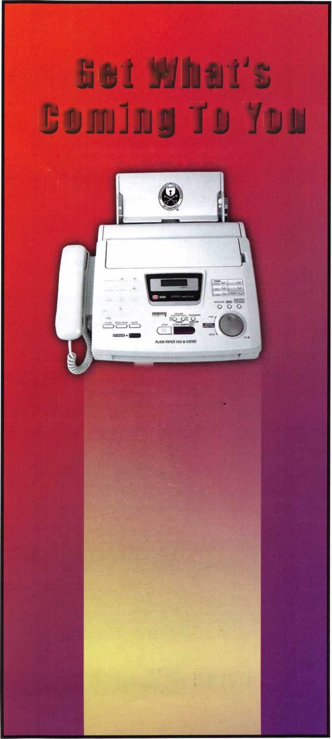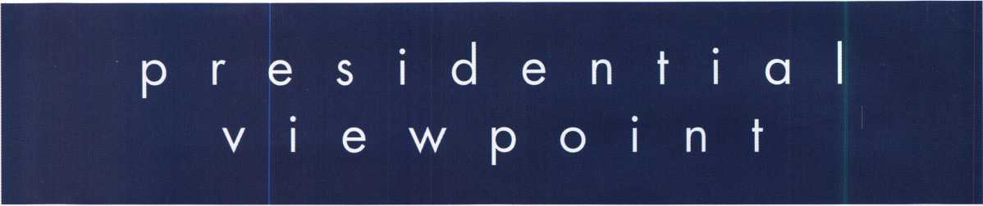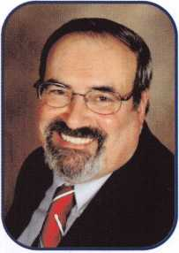

Dear Members,

Toward the front of every Keynotes magazine, there is a page with a lot of information. Staff members and their posi­tions are listed along with all Officers, Directors and Trustees. There is, however, what I consider text of extreme impor­tance, our Mission Statement. In part it reads, that our mission "...is dedicated to enhancing the professionalism, edu­cation and ethics among locksmiths and those in related sectors of the physical security industry". A closer look at the last sentence reveals how we are to fully achieve our mission. "...But it is only through active participation that ALOA can fully achieve its potential-and can help members to achieve theirs."

"We", "our" and "active participation" are at the core of what it means to be a member of ALOA. The Staff and Offi­cers by themselves are not ALOA. It takes every member, pulling together, that will further us as individuals and us as an association. We must invest in ourselves by attending local meetings, shows and taking classes to upgrade our skills. We must invest in others by teaching, mentoring and encouraging fellow members and locksmiths. We must invest in our association by not merely paying our dues, but by communicating our ideas to our fellow members and our Offi­cers. Whenever we do this, we make our industry and ALOA strong. Being proactive and using positive methodology enhances us as individuals.

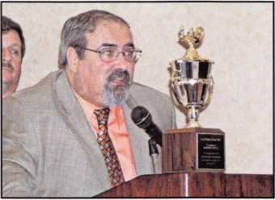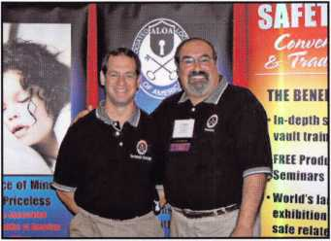

I must truly congratulate and thank the many members and nonmembers I have met this past month. One of the many meetings I have attended in October was the Institutional Locksmiths' Association's conference in New Haven, Con­necticut. After three days of factory tours, classes and meetings, the ILA had a closing dinner. Their guest speakers were from the Discovery Channel show, "It Takes a Thief". The show is sponsored by ASSA Abloy. The show's premise is for the "thief" to break into a house or business (with prior permission of the owner) and then correct the problems which allowed the burglary. Later that evening, I was fortunate to receive the "ILA Mentor Award". Thank you one and all!

A week later, I was in Orlando, Florida to attend the SERLAC Convention. SERLAC had three days of education and a show floor with over fifty exhibitors. Ken Kupferman and I manned the ALOA booth at the show. Later, at the banquet, it was a pleasure to meet with many of the attendees and discuss a multitude of interesting ideas.

As I write this, I am preparing to go to the Greater Philadelphia Locksmiths' Association's Convention. There will be two days of classes; I will be an instructor at one of the classes. At the exhibits, several of your Directors will man the ALOA booth. The convention culminates with a banquet and on the final day, a PRP sitting.

I salute the ALOA members who are true to their mission. They, indeed, have the gratitude of all of us in the security industry.

Take 'er easy!

Sincerely,



Robert E. Mock

Keynotes

November 2006

SCHLAGE

CAL-ROYAL

DOR-O-MATIC

MMimComiK

1 LOCKNETICS

@m COBRA

Mi

LOCKS

'HiCAGO

NATIONAL

, (Pin

**OLYMPUS,^** lF%e LOCK, INC.

7 MBERUNE

**SARGENT**

DON-JO

yiRROW

VON DUPRIN

**$199.50**

LIST $655

**$299.50**

DL2700 26D Lifetime Warranty

hnne sno an ns 1-00 snno xnnz |vH O

**$259.50 $261.00**

MPC06 626 iQ!K/AAE*F

CL210SS

***automotive*** n Ifr

41 DMHNDJ0 **LOCKCRHFTgS**

" " *DETERMINATOR*

*MAJOR HATA*

PRD-LOK

***ACCESS CONTROL***

*Peterson*

**Stbck *Wed$ec&***

*Should you have questions about setting up  
an access control system including:  
wiring diagrams, switches, & installation  
information, give Bill or Paul a call @*

N0RT0

**Special Next Day Air Prices!**

*Place your order by* 5 *PM CST  
& get your order before noon the next day!*

0**ASP** r-COOE **AVENGER**

*Sales Team with over  
65 Years Experience as Locksmiths!*

**LOCKCRAFT^j**

**BIANCHI**

(LAgMA/OR

PRQ-LOK

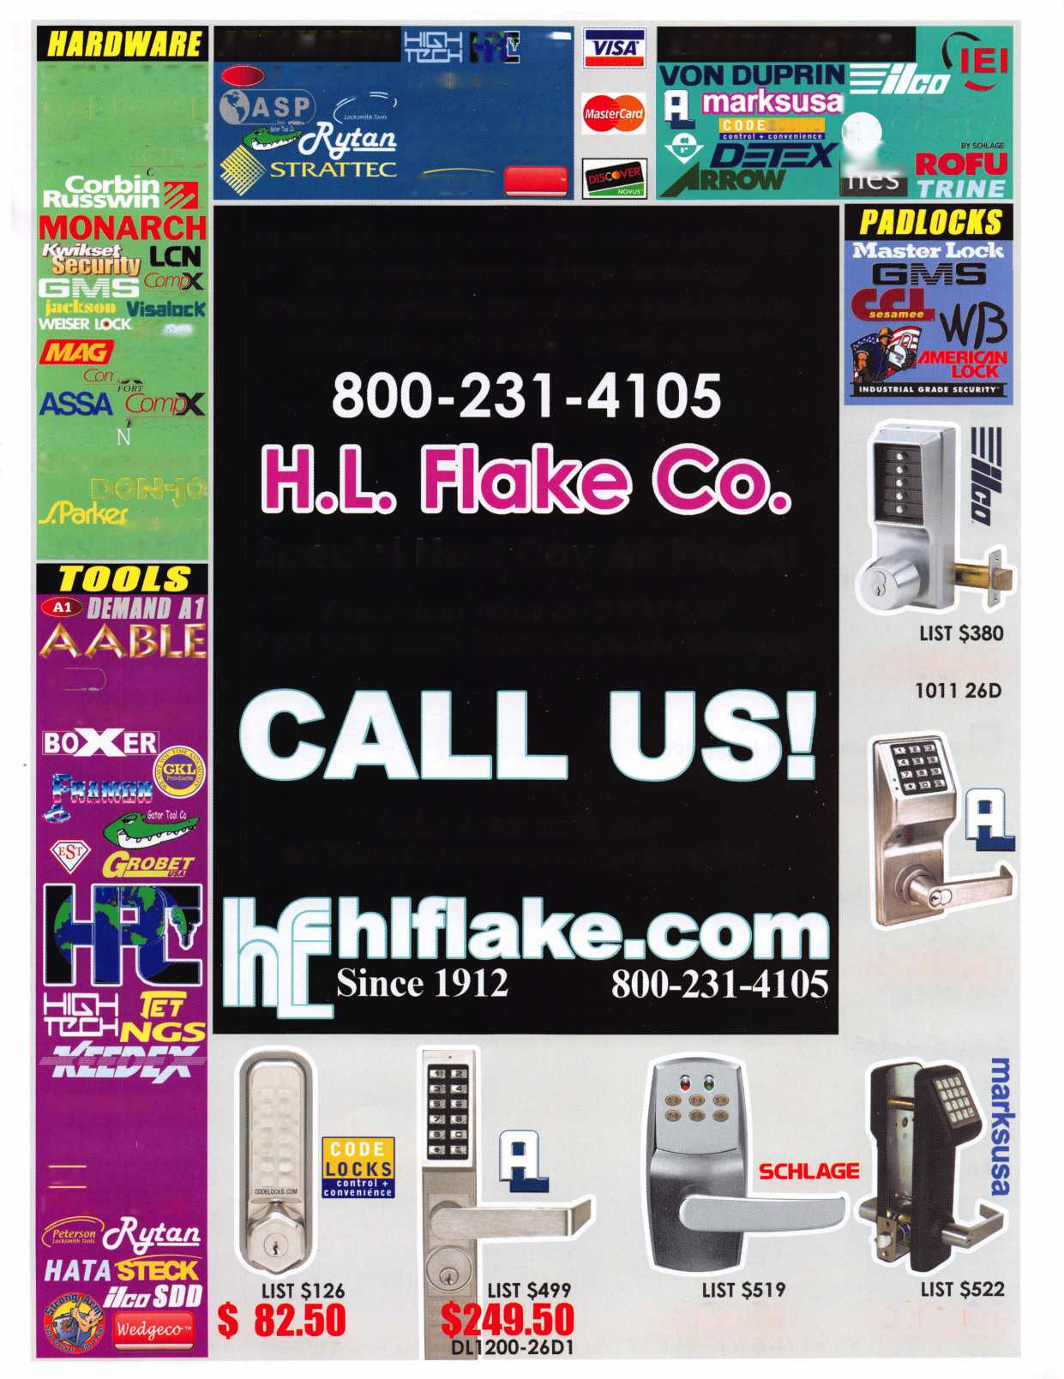

f

e

a

t

u

**res**

SECURITY AT THE PENTAGON 2006

10

NEW FEATURE!

Member Spotlight:

Securing The Pentagon

Check out our new monthly feature spotlighting ALOA members and their lockshops.



Diagnostics WORKS!

How would you handle a lockout, with a drill or your brain?

by Greg Perry CML, CPS

22

Getting Out of the Phone Loop.

What can you do to encourage your customers to remain your customers and not drive them to your competitor?.

by Lourie Brown

**28**

Renegotiating with Integrity

Find out why many times renegotiating is far more essential to your life than negotiating.

by Marc Freeman

**44**

ALOA on Bump Keys

Read this press release to find out what ALOA thinks about the talk surrounding bump keys.

|  |  |  |
| --- | --- | --- |
| r |  |  |
| AD INDEX | |  |
| Allstate | ... Inside Front Cover |  |
| Fax on Demand | 1 |  |
| HL Flake | 3 |  |
| ALOA 2007 | 7 |  |
| Safetech 2007 | 19 |  |
| Clearstar | 21 |  |
| PBP | 21 |  |
| Doorking | 23 |  |
| Inkas | 25 |  |
| Ben Jim | 27 |  |
| ALOA Membership Drive... | 29 |  |
| Vingcard | 31 |  |
| Turn 10 | 31 |  |
| Ultralift | 33 |  |
| Jameson Code | 35 |  |
| Ben Jim | 37 |  |
| A&B | 42 |  |
| Locksmithing UNL | 42 |  |
| E-Key | 42 |  |
| Door Jam Armor | Inside Back Cover |  |
| CCL | Back Cover |  |
| L |  |  |

**Departments**

|  |  |  |  |  |  |  |  |
| --- | --- | --- | --- | --- | --- | --- | --- |
| Presidential | Exec | utive | 5 | Calendar | 8 Classified | 36 | Legislative 40 |
| Viewpoint | 2 App | licants .... | 6 | Core | 9 Associate |  |  |
| ■HHnHI |  |  |  |  | Members | 38 |  |

Visit our NEW website at [www.aloa.org](http://www.aloa.org)

**executive**

Volume 52, Issue 10

Additional contact information for the ALOA Board is available on the ALOA website—  
[www.aloa.org](http://www.aloa.org) or by contacting the ALOA office at 3500 Easy Street; Dallas, TX 75247;  
(800)532-2562; FAX (214)819-9736;

e-mail [aloa@aloa.org](mailto:aloa@aloa.org).

Editor

Betty Southerland [betty@aloa.org](mailto:betty@aloa.org)

Advertising Sales

Kim Hammond voice: 817-645-6778

Fax: 817-645-7599  
e-mail: [adsales@aloa.org](mailto:adsales@aloa.org)

Executive Director

Charles W. Gibson, Jr., CAE [charlie@aloa.org](mailto:charlie@aloa.org)

Associate Executive Director

David Lowell, CML, CMST [david@aloa.org](mailto:david@aloa.org)

Convention & Meetings Manager

Jo Anne Mims [joanne@aloa.org](mailto:joanne@aloa.org)

Operations/Membership Manager

Mary May [mary@aloa.org](mailto:mary@aloa.org)

Director of Creative Services

Betty Southerland [betty@aloa.org](mailto:betty@aloa.org)

Contributors

Jerome Andrews, CML Ray D'Adamo, CML

Paul Chandler, CRL Billy Edwards, CML

Claire Cohen, CML Dan Graffeo, CRL,CMST

Brian Costley, CML, CMST Jim Hancock, CPL

Eric Costley, CRL Jeff Nunberg, CML, CMST

Mission Statement: The Associated Locksmiths of America, Inc. is dedicated to enhancing the professionalism, education and ethics among  
locksmiths and those in related sectors of the physical security industry. With approximately 10,000 members in the United States, Canada and the  
freeworld, ALOA is poised to help members obtain the knowledge, the strength, and the confidence to perform their role in the physical security field  
with pride and dignity. But it is only through active involvement and participation that ALOA can fully achieve its potential—and can help members to  
achieve theirs.

Policies: Keynotes® is the official publication of the Associated Locksmiths of America, Inc. (ALOA). Keynotes® acts as a moderator without approving,  
disapproving, or guaranteeing the validity or accuracy of any data, claim, or opinion appearing under a byline or obtained or quoted from an acknowl-  
edged source. The opinions expressed by the authors do not necessarily reflect the official views of ALOA. Also, appearance of advertisements and  
new products or service information does not constitute an endorsement of products or services featured by the Association. The Association does not  
accept responsibility for the inaccuracy of any data, claim, or opinion appearing in this publication, due to typographical errors on the part of the  
authors, Association staff or its agents.

Editor's Note: This publication is designed to provide accurate and authoritative information in regard to the subject matter covered. It is provided  
and disseminated with the understanding that the publisher is not engaged in rendering legal or other professional services. If legal advice and other  
expert assistance is required, the services of a competent professional should be sought.

Authors' Payment: Payment for eligible submissions to Keynotes will be based on the following criteria: topic, time spent and past contributions. Authors who  
regularly submit to Keynotes® are generally paid a higher rate. The latter is especially true of authors who write to fit specific editorial needs and submit said copy  
by Keynotes® deadlines. As a general guideline: Average payment for a 750 word, business or light' technical article would be $200. Payment for a 1500 word  
article involving significantly higher time and research efforts would be $400.

Payment will not be offered for articles submitted by ALOA employees or members of the ALOA Board of Directors (unless material is of a technical  
nature), nor for articles submitted by a company that promote that company's products or services. ALOA reserves the right not to pay for articles sub-  
mitted by an individual(s) that promote a particular company's products or services.

Disclaimer: The Associated Locksmiths of America, Inc., (ALOA), reserves the right to refuse any article for any reason. Additionally, ALOA reserves  
the right to edit, amend or modify any article submitted for publication in order to preserve technical accuracy, clarity, fairness or grammatical cor-  
rectness. ALOA will make the best efforts to notify the author of any changes. The extent of ALOA's liability for any article or information contained  
therein will be a notice of correction or retraction in the next possible issue.

Keynotes® (ISSN 0277 0792) is published monthly except for the combined June/July issue by The Associated Locksmiths of America, Inc.,  
3500 Easy St., Dallas, TX 75247-6416. Telephone: (214) 819-9733; FAX (214) 819-9736; e-mail [aloa@aloa.org](mailto:aloa@aloa.org). Subscription rates for  
members—$15.00 per year. Periodical class postage paid at Dallas, Texas. POSTMASTER: Send address changes to: Keynotes, 3500 Easy St., Dallas,  
TX 75247-6416. © Copyright 2003, All rights reserved. No part of the contents may be reproduced or reprinted in any form without prior  
written permission of the publisher.

Director of IT Operations

Greg K. Jackson [greg@aloa.org](mailto:greg@aloa.org)

Membership Development Manager

Ellen R. McEwen [ellen@aloa.org](mailto:ellen@aloa.org)

Membership Coordinator Shelly Jett

Convention & Meetings Assistant Karen Lyons PRP/Education Coordinator Shelley Melton

Mail Room Coordinator Kevin Wesley

Graphic Designer Margarita Garza

Accounting Coordinator Joyce Nixon

Executive Assistant Sue Langford

Assistant Education Manager Bob Stafford

Legislation Manager Tim McMullen

Randy Simpson, CML, CPP Tom Seroogy Robert Stafford, CML Charles Stephenson, CPS

Dave Thielen, CML Dennis Watanabe, CML, CMST

Greg Perry, CML,CPS



President

Robert Mock  
(856) 863-0710  
[president@aloa.org](mailto:president@aloa.org)

Secretary

John Soderland, CML, CMST  
(414)327-5625  
[secretary@aloa.org](mailto:secretary@aloa.org)

Directors, Northeast

Tom Foxwell  
(410) 206-5772  
[nedirector@aloa.org](mailto:nedirector@aloa.org)

Robert D. DeWeese, CML  
1410) 285-0101  
[nedirector@aba.org](mailto:nedirector@aba.org)

Directors, Southeast

Tom Gillingham, Jr., CML, CPS  
(615) 2640747  
sed i rector@aloa. org

Ken Kupferman, CML  
(813) 232-7600  
[sedirector@aloa.org](mailto:sedirector@aloa.org)

Director, North Central

Wiliiam Smith, RL (920) 893-5282 Guy Spinello, RL (815) 394-1000 ncdirector@aloa .org

Director, South Central

CD Lipscomb, CML, CPS  
(903) 874-3522  
scd i rector@aioa. org

Directors, Southwest

Greg Parks

(858) 271-1155  
[swdirector@aloa.org](mailto:swdirector@aloa.org)

Julie McCiuney, CRL  
(714) 636-5652  
[swdirector@aioa.org](mailto:swdirector@aioa.org)

Director, Northwest

Keith E. Whiting, CML, CFL  
(360)601-5656  
nwdireetor@a!oa .org

Director, European

Hans Mejlshede, CML  
(453) 539-3939  
[eurdirector@aloa.org](mailto:eurdirector@aloa.org)

Director, Associate

Dan Floeck  
(800)231-4105  
[asdirector@aloa.org](mailto:asdirector@aloa.org)

Trustees

[trustees@aloa.org](mailto:trustees@aloa.org)

Randy Simpson, CML  
(281) 240-5959

johnj. Greenan, CML, CPS

(773) 486.2030

William Young, CML, CPS  
(610) 647-5042

Past Presidents

2003-2005 William Young, CML, CPS  
2001-2003 Randy Simpson, CML  
1999-2001 John Greenan, CML, CPS  
1997-1999 Dallas C. Brooks  
1995-1997 David Lowell, CML, CMST  
1993-1995 Breck Camp, CML  
1991-1993 Henry Printz, CML  
1989-1991 Evelyn Wersonick, CML, CPS  
1987-1989 Leonard Passarello, CPL  
1985-1987 Joe Jackman, CML  
1983-1985 Stanley Haney, CPL  
1981-1983 Louis LaGreco, CPL  
1979-1981 John Kerr, RL  
1977-1979 Clifford Cox, CML  
1974-1977 Charles Hetheringfon  
1972-1974 Gene Laughridge  
1970-1972 William Dutcher, RL  
1968-1970 Constant Maffey, RL  
1966-1968 Harold Edelstein, RL  
1964-1966 William Meacham  
1962-1964 Robert Rackliffe, CPL  
1960-1962 Edwin Toepfer, RL  
1956-1960 Ernest Johannesen



Keynotes • November 2006

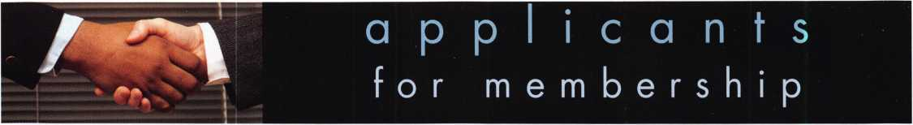

CA

Ontario

Daniel Kane

Sponsor: Gory L. Williams CML Sunnyvale

Jeff S. Sanchez

Sponsor: Thomas M. Stiver

CT

Wallingford

David Perrotti

Sponsor: William E. Forson CRL

FL

Clearwater

Moran Bierman

Miami

Jose M. Rivera

Naples

Benton L Bryan John J. Kennedy Troy Pirosseno

Pompano Beach

David U. Logan



Mahomet

Scott M. Azwell

IN

Indianapolis

Steven G. Wiese

Sponsor: Doug B. Stong

LA

Mandeville

Guy T. Robinson CRL

Sponsor: Ajae F. Hardeman Jr; CRL

MD

Frederick

Roger L. Moore

Sponsor: Philip A. Rovenolt CPL Gaithersburg

Ronald C. McClain II

Sponsor: Joshua A. Higgins Germantown

Carlos R. Orellana

Sponsor: Joshua A. Higgins Silver Spring

Geoffrey K. Buckler

Sponsor: Jerome T. Peck CPL

NJ

Pemberton

Lionel M. Murphy

Washington Township

Raymond M. Roosa

NM

Albuquerque

Donn Meilak

OH

Cincinnati

Michael McDonough

OR

Newberg

Bryan Joyce

Sponsor: Michael Elsberry CRL

TN

Millington

Tony L. Scott

VA

Arlington

Evan B. Morgan

Sponsor: Michael B. Groves Stafford

Shawn A. Duncan

Sponsor: Michael B. Groves Virginia Beach

Tammara Weaver

Great Britain

London

Philip Sargent

Sponsor: Ken Dale

These applicants are scheduled for clearance as members of ALOA. The names are published for member review and comment within 30 days of this Keynotes issue date, respectively, to ensure  
applicants meet standards of ALOA's Code of Ethics. Protests, if any, should be addressed to the Membership Department and must be signed. Active Membership applicants (a) have worked in  
the industry two or more years. Allied Membership (AL) applicants are not locksmiths, but work in a security-related field. Apprentice Membership (AP) applicants have worked in the industry less than two years.



Keynotes • November 2006



Start Your Engines!

This year, with a great location and a  
schedule chock-full of exciting classes  
and events, we are pulling out all the  
stops to celebrate the ALOA Convention  
and Security Expo in Charlotte, North  
Carolina.

Having built an international reputation  
among locksmiths as a powerful resource  
to explore industry innovation and form  
industry alliances, ALOA 2007 is the ideal  
place to learn, network or to showcase  
your security-related business on the  
show floor.

This year we've thought of everything  
from an exciting location to a comfort-  
able hotel and a convention center that is  
equipped to handle your every need. The  
exhibit hall promises to be overflowing  
with the latest technology and new mer-  
chandise.

july 22-29, 2007

charlotte, north Carolina

|  |  |
| --- | --- |
| 1 / — | |
| N 4 5  *<,OOOr/r"in |  |
| '*2 | |
| • | 7 { |
| SQ Al-°A 2°°7 |  |

aloa convention and security expo

*51st ANNUAL*

Don't miss out!

800-532-2562

upcoming events

11/18 OMLA Class - Access Control, CCTV, Nurse Call, Etc Contact: John Ruperd (417)-926-3689

12/4 Dallas, Texas • ACE Classes ALOA Training Center Contact: [education@aloa.org](mailto:education@aloa.org) 800-532-2562x104

2/14 TLA Convention • Houston, Texas. [www.texaslocksmiths.org](http://www.texaslocksmiths.org)

**UPCOMING ACE CLASSES**

December 4, 2006 January 13, 2007

January 13, 2007

February 10, 2007

March 28 - 30, 2007

April 21, 2007 April 26 - 28, 2007

May 7- 12, 2007

July 8- 16, 2006

Dallas, Texas • ACE Classes • ALOA Training Center Contact: [education@aloa.org](mailto:education@aloa.org) • 800-532-2562x104 Detroit, Michigan • Locksmiths Security Association Robert C. Noble, CML • Interchangeable Core Fundamentals

<http://home.earthlink.net/~lockwriter/idl> .html [noblelock25@sbcglobal.net](mailto:noblelock25@sbcglobal.net)

Casper, Wyoming • Wyoming Locksmiths Association Gene Ficek, CPL • Automotive Update with Trandsponders

Detroit, Michigan • Locksmiths Security Association Robert C. Noble, CML • Basic Electricity & Electronics w/Ll 3 PRP

<http://home.earthlink.net/~lockwriter/idl> .html

[noblelock25@sbcglobal.net](mailto:noblelock25@sbcglobal.net)

Vancouver, British Columbia • British Columbia

Association of Security Professionals

Bill Beazley • 14 ALOA Certified Classes

[lockpicker@helmz.com](mailto:lockpicker@helmz.com)

Kearney, Nebraska • Nebraska Chapter of ALOA Elmer Howard • Push Button Mechanical Lock Manipulation • [safeman@cox.net](mailto:safeman@cox.net) Denver, Colorado • Central & Southern Colorado Locksmths Association • Barry Meyers, CPL 9 ALOA Certified Classes Dallas, Texas • ALOA Training Center ALOA Education

Six-Day Basic Locksmithing Course [www.aloa.org](http://www.aloa.org) • [education@aloa.org](mailto:education@aloa.org) Charlotte, North Carolina • ALOA 51st Annual ALOA Education • 80 full day classes Convention & Security Expo • [education@aloa.org](mailto:education@aloa.org) 40 half day classes & evening seminars [www.aloa.org](http://www.aloa.org)

August 20 - 25, 2007

October 15-20, 2007

December 3 - 8, 2007

Dallas, Texas • ALOA Training Center ALOA Education

Six-Day Basic Locksmithing Course

[www.aloa.org](http://www.aloa.org) • [education@aloa.org](mailto:education@aloa.org)

Appleton, Wisconsin* Fox Valley Technical College

Ann Kading • Six-Day Basic Locksmithing Course

<http://www.fvtc.edu/tp2.asp?ID=Security%2FCrime+Pre>

vention&pix=005

Dallas, Texas • ALOA Training Center ALOA Education

Six-Day Basic Locksmithing Course [www.aloa.org](http://www.aloa.org) • [education@aloa.org](mailto:education@aloa.org)

**UPCOMING PRP Sittings**

11/11/2006

11/19/2006

11/16/2006

12/9/2006

2/10/07

2/11/07

2/17/07

3/10/07

3/31/07

4/28/07

4/28/07

5/12/07

Saturday 8:00 am • Cary, NC • North Carolina

Locksmith Assc. • Granger L. Marley 919-859-6060

Sunday 8:00 am • St. Louis, MO • Bi-State Chapter of

ALOA • Kenneth Kim, CRL, CPS 314-351-7252

Thursday 9:00 am • Dallas, TX • ALOA

ALOA Certification 800-532-2562 x203

Saturday 3:00 pm • Dallas, TX • ALOA

ALOA Certification 800-532-2562 x203

Saturday 8:00am • Roseville, Ml

Locksmith Security Association

Sunday 8:00am • Welch, MN

Minnesota Chapter of ALOA

Saturday 8:00am • Houston, TX

Texas Locksmiths Assn.

Saturday 8:00am • Lexington, KY SAFETECH2007

Saturday 8:00am • Vancouver, BC

British Columbia Association of Security Professionals

Saturday 8:00am • Roseville, Ml

Locksmith Security Association

Saturday 6:00pm • Denver, CO

Central & Southern Colorado Locksmiths Association

Saturday 3:00pm • Dallas, TX • ALOA Training Center

**Contact the ALOA Education Department for a list of classes and training**

**offered in-house.**

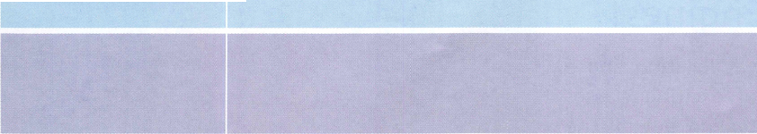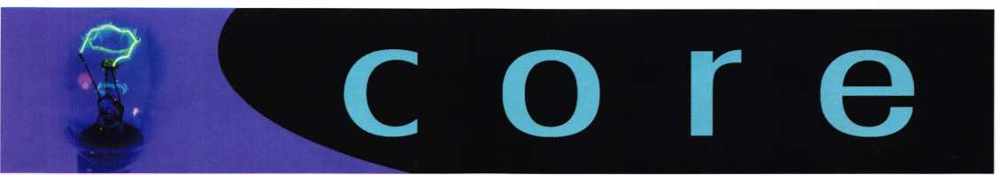

GPLA Flag

At their annual convention in October of 2005, the Greater Philadelphia Locksmiths' Association hon­ored the men and women, past and present, of the armed forces of the United States. In appreciation of this patriotic gesture, U.S. Senator Rick Santorum of Pennsylvania presented GPLA with a flag that has flown over the nation's capitol. The certificate that accompanied the flag is pictured here. It reads:

"This is to certify that the accompanying flag was flown over the United States Capitol on December 12, 2005, at the request of the Honorable Rick Santorum, United States Senator.

This flag was flown for the Greater Philadelphia Locksmiths Association in thanks for their sincere show of military support."

Kaba Traveling Road Show

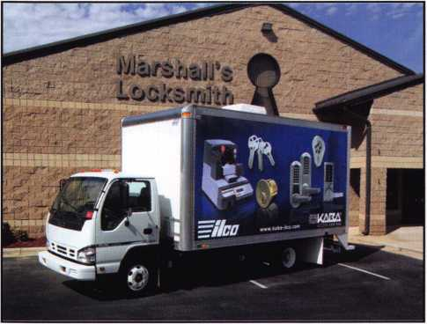

OF AMERICA.

*■*» «?***» *tow» <***

***** tern* m U /»*».«**

of 0* H«***bfc SM*wwtn.

tkte flag **wh** ikwn Is* I be tackMMifc

AwttCfMkm tat thani* far rbre* waeete An* « nwlttan wtt&t.

Mb^Otl73l-OOt

**AUnM**

**Arebrtaci of *b\***

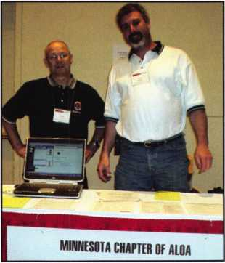

Board Secretary John Soderland, CML,CMST,CIL was on hand to answer member­ship questions in Minneapolis dur­ing the Doyle Security Trade Show in September.

Kaba Access Control and Kaba llco are proud to announce that a traveling show of product demon­strations has hit the road in the Americas. This mobile show is loaded with hands-on demonstrations of llco's wide selection of key systems and key dupli­cating equipment, as well as Kaba Access Control products - all designed to help you increase your awareness of the latest available technologies and gain a better understanding of how Kaba can help you take control of your key system and access con­trol needs. The Kaba traveling road show is open and ready for demonstration in locations across the United States and Canada. To find out when this show will be in an area near you, ask your distribu­tor or go to [www.kaba-access.com](http://www.kaba-access.com) and look under Trade Shows & Events, then Traveling Road Show.



**MEMBER\***

potlight

Welcome to our new monthly feature! Each month we will highlight a current ALOA mem­ber & their lockshop with a short bio and in-depth questions. To be considered or to recom­mend a fellow ALOA member please read the information provided at the end of this article.

Our shop is a fully-functioning lockshop located in the Pentagon. Our mission is to provide lockshop-related security services and support to all components of the Office of the Secretary of Defense to include the immediate offices of the Secretary and the Deputy Secretary of Defense in the Pentagon and in the National Capital Region. We were once called the Defense Protective Service, but after Sept. 11th a new agency was formed and we became the Pentagon Force Protection Agency (PFPA). The Pentagon Police are also part of the agency. We fall under the Security Services side of PFPA. We deal with some of the old Corbin locks that have been in the building since it was built, high security key locks, both Medeco and ASSA, various brands of security containers (safes), and vault doors. Some of our functions are installation and repair of all locking devices, install and repair all com­bination locks, repair malfunctioning safes, open security containers by drilling or by dialing, maintain a master key system, oversee the lock instal­lation in the Pentagon Renovation project, and occasionally cut desk or cabinet keys. The shop consists of three permanent security specialist/lock­smiths and one contractor assigned to install locks in renovation. The per­manent employees are myself, Marion Cochran Jr. (better known as "Snake”) 36 years in security and 27 as a locksmith, Mike Dooley, 27 years in security and 17 as a locksmith, and Rob Pelletier, 8 years in security and 7 as a locksmith.

1. Tell us about your  
   background in secu-  
   rity and your experi-  
   ence in locksmithing.

*Cochran:* I was in the  
Air Force as a Security  
Policeman for 11 1/2  
years. 10 1/2 years was  
right here in the DC  
area. The only time  
away was a tour  
in Vietnam. While  
stationed at the

Pentagon, L became interested in locksmithing, took the  
Locksmithing Institute correspondence course, got a part  
time job as a locksmith at A-1 Lock & Safe Service  
which was owned by Tom Demont, now with ASSA.  
When I left the AFI worked there about 4 more years  
and then this position came available at the Pentagon as  
a Security Specialist and I've been here as a government  
worker since Sept. 1985.

*Dooley:* In 1989 while in the Air force I got stationed at the Pentagon to perform law-enforcement duties within the Air Force areas of responsibility. Due to the uniqueness of the building, the squadron had a locksmith position for locks in all Air force areas (approximately 600 rooms). I thought it would be interesting so I applied and was selected. I worked in that shop for about 8 years. I then went on special-duty assignment to the Office of the Secretary of Defense in their lock shop and worked there until I retired from the Air Force in 2000.

I then returned to the same shop as government employee. We currently maintain approximately 1000 openings.

1. What is your favorite place in DC? And why?

*Cochran:* I think probably the Smithsonian and the new Air and Space museum bcause of all of the history that's on display. The bad thing about being in the area per­manently is that you tend to take it all for granted. *Dooley:* All of Washington DC is interesting. The City is breathtaking at nighttime. No matter how many times I go into DC sight seeing, I always see something new.

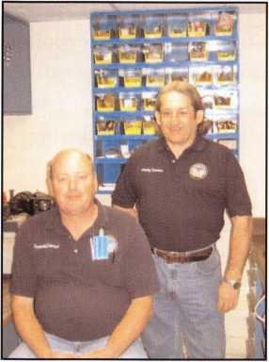

1. In your experience, do find that the DC area requires more security than other cities?

*Cochran:* I would say, "yes ". Everything here is so visible and in the public eye that the possibility of being a ter­rorist target is very real.

*Dooley:* I'm sure it does mainly due to the amount of federal offices located so closely together. Every agency has its own security requirements and every Fire Marshal is a little different than the next on what they will and will not allow. Currently integrating life safety and ADA requirements into security is the biggest challenge.

1. Washington has a rich tradition of locksmithing. How did you get involved in the business?

*Cochran:* Part time job as explained previously and then the government job at the Pentagon.

*Dooley:* After I was selected to work in the lock shop with the Air Force I knew I needed to learn as fast as possible.

I started taking classes and attending seminars when ever I could. I did this after work and on weekends most of the time. Several years before I retired I worked part time for a local lock company "Chancellor Lock and Key ” owned by Jerry Musselman. I wanted to learn more about resi­dential and automotive locksmithing. I worked mainly on weekends. I really enjoyed working for Jerry. He allowed me to learn at my own pace and taught the automotive side with ease. I think doing automotive is the most chal­lenging work due to the vastness of models, and makes of vehicles (not to mention the weather conditions you have to endure while working on them).

1. Tell us about the changes youVe seen in security technology recently.

*Cochran:* The main changes that affected us was the move from the mechanical combination locks such as the Mosler 302 and the S&G 8400 and 8500 series locks to the digital combination locks made by Mas Hamilton (now Kaba Mas). First there was the x-07, then the X- 08, and now the X-09. We generally don't go very high tech on access control. We just use a Unican 4000 or the the new E-Plex 5000. We have a few areas where biomet­ric was installed, but we didn 't complete the install.

Keynotes • November 2006

***Dooley:*** The most obvious changes are the amount of electric locks on the market now. Locksmiths of today can no longer rely on doing only mechanical locks. The intro­duction of the computer years ago changed everything. A locksmith now also has to be a salesman in order to sell electrified locks. They have to be able to demonstrate the new capabilities to the customer and then be able to install the program and maintain them down the road. Nomenclature of the locks is greatly important now in order for the manufactures to properly ship parts and diagnose problems.

1. **Do you find that other locksmiths in the DC area work together on referrals and workflow? *Cochran: I*** really can't say. We deal mainly with other government locksmiths. I work part-time at a local com­pany, Baldino s Lock & Key, but that’s usually just shop work on Saturdays to give the other guys a break.

***Dooley:*** Working for the government, we don’t have much interaction with local locksmiths regarding referrals or workflow. I do know many locksmiths in the area as friends and when we get together we share information.

I do have to say that when I first started working as a locksmith getting information from a seasoned lock smith was not easy. Sharing information 10 to 15 years ago was like pulling teeth. It seems to have loosened up over the years. Realizing this, I have always tried to share as much as possible.

1. Do you feel that the locksmith industry has got­ten a bad rap lately in the news?

***Cochran: I*** do feel that they have. ***I*** read about a couple of the horror stories where someone called in for a simple lockout, being quoted a low price but when the service arrived, the phony locksmith just drilled out the lock and charge outrageous prices for a replacement.

***Dooley:*** I believe they have. Sure as with any industry there are bad people. This was my biggest concern when I was working part time. I always went to the extreme to identify who I was working for (see ALOAs Positive Id Policy for more information). The mobile lock smith is an easy target. I do believe that the majority of lock smiths are honest and hard-working individuals.

1. In 2001, after the attack of September II, you helped to safeguard classified materials by opening more than 80 damaged safes that were removed from offices near the Pentagon's ruined west face. What was the biggest challenge you faced during this process?

***Cochran:*** The number was actually over 200 safes that were opened! Probably the biggest challenges were the long hours and dealing with the endless flow of security containers that were pulled out of the wreckage and delivered to the outside area where we opened the safes.

At the same time, we were working our regular job in the Pentagon which didn't stop.

***Dooley:*** Working at the Pentagon we deal with all facets of locksmithing. Opening Government Security Containers (safes) is also part of our job. I responded to the location where the damaged safes were being stored. They were either physically damaged (bent, twisted, etc) or burned with all external hardware missing. Seeing this I realized that traditional techniques would not work. We purchased 2 sets of ’’Jaws of Life ” which were hydraulically operated. We lined the safes up and went down the line ripping and bending them open one by one. Every drawer had to be forcibly removed. All in all I opened well over 200 safes and the majority were five- drawer safes. While doing this we still had to respond to basic lock problems in the building.

1. Can you give us some statistics on physical security at the Pentagon? How many locks do you service, for example?

***Cochran:*** We are responsible for over 1000 openings in the Pentagon. Some of these may be just regular office doors or they could be vault doors, or internal doors that require addition protection. We are also responsible for the perimeter doors to the Pentagon.

***Dooley:*** We service mostly grade 1 locks like Schlage, Arrow, Medeco, Yale, and Corbin cylindrical and mortise locks, (mechanical and electrified). We use both IC core and non-IC core. We also use both mechanical and elec­trified stand alone access control devices. We use combi­nation locks from S&G and Kaba-Mas products for safes. So I guess you could say we have everything.

**12**

Keynotes • November 2006

1. Can you remember your first big security job?  
   What can you tell us about it?

*Cochran and Dooley:* From day one, each job is unique  
either due to the size or whose office you are working in.  
We perform work for the highest-ranking people within  
the department of defense.

1. What has been your most exciting project  
   to date?

*Cochran:* This isn't lock related, but when *I* first arrived  
at the Pentagon, part of the section that I was assigned to  
had the duties of the protection of the Secretary of Defense,  
at that time was Caspar Weinberger. They were basically  
like his Secret Service. Every so ofien, when they had a big  
event and needed help, we were sworn in  
as Special Deputy US Marshals so

that we could be armed to  
assist if needed. It was

quite exciting  
because usually  
when we were  
needed, the  
President was  
coming over.

*Dooley:* Renovation of the Pentagon  
is probably the biggest. We oversee the

installation of all combination locks installed on  
doors as required. When the installer gets behind, we  
get involved and help hi catch up. At times it can be  
very hectic.

1. What advice can you give to an aspiring  
   security professional?

*Cochran:* Get as much training as possible. No matter how much you think you know, everything is constantly changing.

*Dooley:* Be open minded. Locksmiths have a tendency to be a little conceited. I think it comes from working alone a lot and taking pride in seeing a job done correctly and professionally. You must be a selfstarter, dependable, and

honest. People rely on you to do your job right and do it in  
a timely manner. Dontforget to clean up before  
you leave a job.

1. How do you stay informed about new products  
   and security techniques?

*Cochran:* By attending security shows, seminars, and  
training. Also, we have several vendors that bring in new  
products for us to investigate.

*Dooley: I* figured out early that *I* needed to prove myself  
in the industry and establish a good reputation. Working  
here at the Pentagon, lock manufactures are very willing  
to assist us in staying current on their products. We con-  
stantly test products to determine whether they are feasible  
for our use. I like to think I am

different from a lot of other

shops in that I tell the

manufacturer  
what I liked  
and didn t  
like about the

product. If and

when we find a problem,

I not only tell them, but show

them what is wrong and try to come  
up with a solution.

1. How do you sell security to the public?

*Cochran:* We don’t sell security to the public. Here we just say, ''this is what you re getting since the things we pro­vide are mandated by security requirements. I do get a chance on my Saturday work at Baldino s to deal with the public and show the various brands of security locks and safes when customers come in.

*Dooley:* I only did this while working part time. You have to balance what the customer wants and what is needed and show the difference between the low end prod­ucts and heavy-duty ones. You must be able to show the pros and cons. You must also be aware of what the cus­tomer can afford.

Keynotes • November 2006

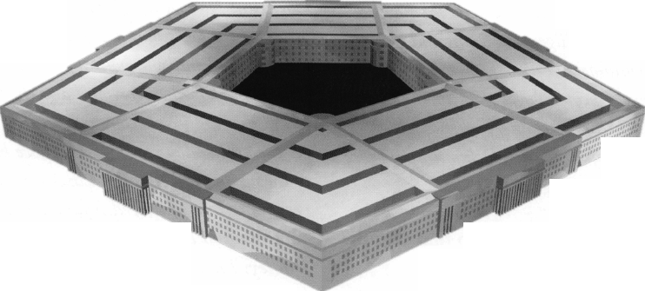

1. Where do you see the future of security going? Where are we headed in today’s age of technology considering these times of high security?

***Cochran:*** I see more emphasis on high-security locks that emphasize key control and more interest in biometrics. Our requirements here are pretty much dictated by secu­rity regulations and by the types of locks that are approved for the protection of classified material.

***Dooley:*** Smart chips are a big topic. However they

are basically only the logic portion of a locking device.

The basic mechanics of a lock will still be the same.

1. **In these times, what do you think is the biggest obstacle facing security professionals, if any? *Cochran:*** I don't see it as an obstacle but with the con­stantly changing technology, the security professional must stay abreast of the latest advances and new products so that he is able to make intelligent decisions and recom­mendations to his customer.

***Dooley:*** Getting young people to get into the industry and stay is difficult. I think pay and benefits are big obstacles. I can't think of many rich locksmiths andface it, locksmiths work some strange hours.

1. Name one thing in your lockshop that says the most about you.

***Cochran:*** Tm very proud of the type of customer service that the shop provides. Once the shop gets a call about a problem, the call is handled in a very timely manner and callbacks are almost nil.

***Dooley:*** Callbacks. We have almost no callbacks on jobs. This is due to pride and professionalism. The other thing is our key machine room. We have one of the best assort­ments of machines around and use them daily. They range from a manual duplicator to an automatic originator. Certain machines are dedicated to specific

1. What do you like most about your job?

***Cochran:*** I would say the fact that in the Pentagon, our shop is considered the "go to " experts for security-related questions and problems, plus the fact that we constantly deal with all levels of personnel, from a secretary in an office, one of the Pentagon Police Department officers, or the immediate office of the Secretary of Defense.

***Dooley:*** Everything. ***I*** love my job and profession. ***I*** real­ly enjoy the feeling I get when I respond to a lockout, open it and complete the repair in such a way that you couldn't tell we were even there.

1. How has life changed for you as a locksmith in the past few years? Do you feel a personal responsi­bility to secure the U.S.?

***Cochran:*** No really big changes. Our shop is resposible for all of the locks that are installed in the Renovated areas of the Pentagon, both the CDX-09 digital combi­nation locks on the doors and also the high security key locks, so as an area is completed, it gets sort of hectic to get everything done prior to the space being turned over to the occupant. Yes, we feel that we indeed provide a very important and needed function and take pride in doing our job well.

***Dooley: I*** don't know of any changes. This is what ***I*** have been doing for 17 years.

1. Do you feel a bigger sense of pride as a work­ing locksmith for the Pentagon?

***Cochran:*** Yes, I feel proud to be a working locksmith at the Pentagon. I've been here so long, almost everywhere I go, I get people saying "Hi Snake". I think more people know me by that name than my real name.

***Dooley: I*** do. ***I*** come from a military family ***I*** have one brother in the Air Force stationed down the road from the Pentagon and my older brother is a federal employee at Tinker AFB, Oklahoma. I have worked here so long, I can't imagine working anywhere else.

**14**

Keynotes • November 2006

1. Name a few things that locksmith business owners should do to help their businesses prosper and grow.

*Cochran:* I can't make many suggestions on this since I'm totally removed from the regular side of the locksmith business. I would say i(stay knowledgable about the latest advances in the field so that you are able to give the cus­tomer the best advice and recommendation”. Also, adver­tise and provide a wide variety of services from high-secu­rity locks, safe servicing, and automotive (including transponder keys and service). I'm limited on this since we don't deal with them at the Pentagon but I get some exposure at Baldino's on Saturdays.

*Dooley:* I'll defer on this. We are a not-for-profit office.

1. Give us your biggest locksmithing horror story, toughest job, or the job that taught you the biggest lesson.

*Cochran: I* would say the biggest horror story would be the aftermath of Sept 11th and all of the additional work that we were tasked with. I think the toughest job would be the current job of trying to stay on top of all of the lock installations and service in the renovated areas of the Pentagon.

*Dooley:* On my part time job, I was thirty miles from home about 2 am in the middle of nowhere. Making an automotive key and discovering the vehicle had a transponder and not having the equipment was horrify­ing. It taught me to stay more current on changes.

1. What is the best part of being a locksmith in America today?

*Cochran: I* think the best thing is the opportunities that are available if you make the effort and the ability to possess a skill that will constatly be needed.

*Dooley:* Probably the various types of locks and cylinders both foreign and domestic that you encounter.

1. Explain the rewards of being an active partici­pant in the profession as a whole, as opposed to someone just spinning their wheels trying to make ends meet at a shop.

*Cochran:* I would say the rewards would be the vast amounts of knowledge and expertise that is out here and is available either from the lock manufacturers or other locksmiths. No matter how long you do this job, you can always learn more. There is always someone out there that has encountered a problem that you haven't. It's very inportant to be able to tap into this vast pool for advice if needed.

*Dooley:* Basically its self motivation. I've followed a lot of the work that has been done to strengthen the industry through certifications and background checks. A lot of the bigger shops hold seminars and workshops supported by the manufacturers. Training and willingness to share information will only make the industry stronger.

**\*You must be a current member of The Associated Locksmiths of America in order to be recommended for our Member Spotlight feature. If you would like to be recommended or would like to recommend someone else please email our Keynotes Editor, Betty Southerland at [betty@aloa.org](mailto:betty@aloa.org).**

Keynotes

November 2006

Dialing Diagnostics WORKS!

by Greg Perry, CML, CPS

How would you handle the lockout, with a drill or your brain?



**6**

Keynotes • November 2006

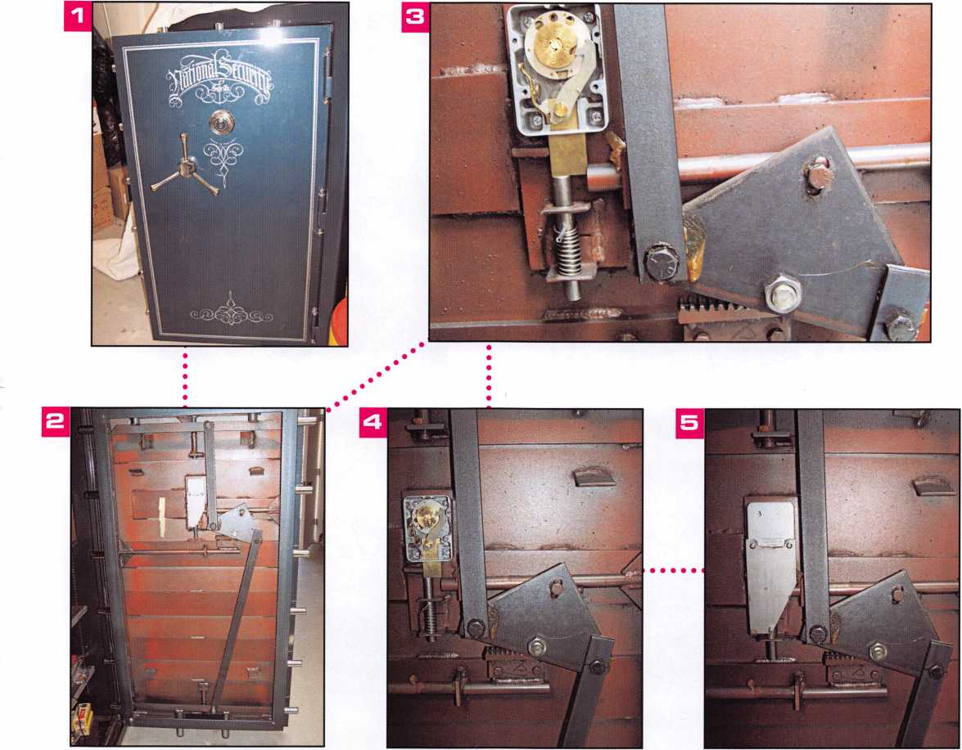

This month, we’ll look at a couple of gun safes. In both cases, the customers were certain I would need to destroy something to get the safes open. Watching some of the posts on Clearstar Security Network, I find it interesting to see how others approach a lockout. Some will spend time at the container going through the diagnostics and then post for other safecrackers to comment and help formulate a plan. Others simply ask for a drill point. Forget diagnostics. Forget looking in their own library (some may not have a library). Forget even visiting the container first to use their tal­ents and knowledge. Instead they cut to the chase, asking “Where do I drill?”

Brian Costley, CMST, CML of Sargent and Greenleaf has written two great primers on diagnostics. The first

is Dialing Diagnostics, which is now incorporated into the S&G Mechanical Safe Lock Manual that is available as a download at [www.sglocks.com](http://www.sglocks.com). The second is avail­able from the ALOA store titled “Logical Lock Diagnostics”. Both of these safes could have been drilled, instead with a little inspection and dialing diag­nostics both were open within minutes of my arrival.

The first safe seen in photos 1 through 5 is a National Gun Safe. The customer had the combination but it would not open. Before touching the dial I asked the customer to dial the combination while I watched. I like to see how they dial; do they spin the dial so fast it smokes? Do they dial it 4 times left, 3 times right, 2 times left and back to the stop around 95? Do they pass their number by 5 and then back up? This time

Keynotes • November 2006

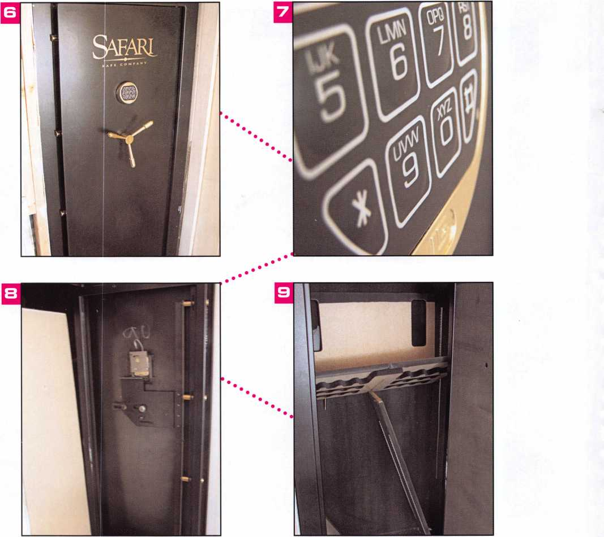

the customer dialed the lock correctly. Now it was my turn. Starting with a spin of the dial, I noticed the lack of contact points. Sometimes they are faint and hard to feel but they should be there. Obviously the safe did not open. Based on the lack of contact points, here are some possible problems, first and most likely, is a stuck lever; second is a broken lever spring and, third the fence rides on the wheels were not allowing the lever nose to touch the drive cam. The customer added a few more details at this point. He said the lock wouldn’t always “catch” and that it was steadily getting worse over the last couple of months.

How would you solve this lockout? (Also look closely at photo 5, do you see a problem?) While you think about it, lets look at the second safe.

This safe seen in photos 6 to 9 was brand new, pur­chased from Costco. It’s a Safari made by Cannon safe. Costco had loaded the safe on it’s back into the back of the customer’s pickup truck for the 100-mile ride home. Once there, the customer manhandled it through a small back door and shoved it into an opening he made in a closet wall. Based on his description of how he did it, I’m surprised the safe stayed upright. Since this safe

**8**

Keynotes • November 2006



***THE RACE STARTS HERE***

MARCH 5th thru MARCH 10th, 2007

**LEXINGTON**

**KENTUCKY**

**This year  
we’re back in  
LEXINGTON  
' for the 150th  
Anniversary  
of Sargent &  
Greenleaf.**

**Keeping up with the  
latest the industry has  
to offer has never been  
this important - or this  
FUN! When it comes to  
learning about the latest  
in safes and vaults, time  
is of the essence.  
SAFETECH** 2007 **fea-  
tures an all-new menu of  
classes, covering every  
safe topic on the globe.**

*OUR SAFETECH 2007*

*SPONSORS!!*

**SARGENT AND GREENLEAF**

**SAFETECH**

**LEXINGTON’S**

READY.

**ARE YOU?**

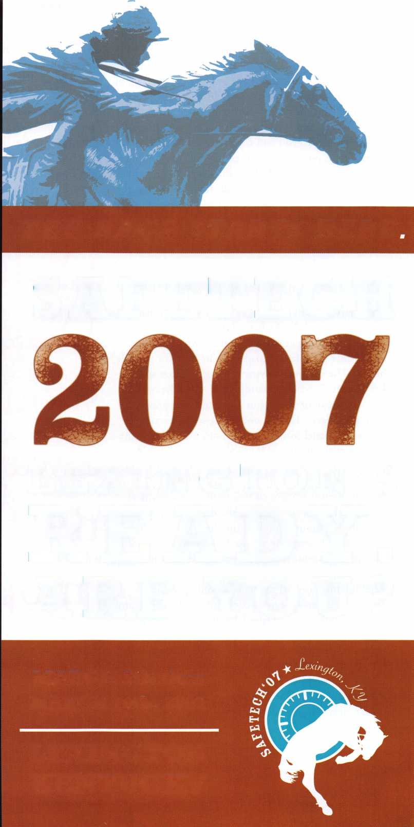

comes with LaGard LG Basic electronic lock, the fac­tory combination is 123456. It operated at the store but it wouldn’t work once the customer put the safe in place. The only buttons that would make any beeps were the * and the # keys. Normally these are not sup­posed to beep and have no function. Upon arrival, I glanced at the keypad and then checked behind the keypad for a pinched wire or cut cable. Not finding any problems I looked back at the keypad. This time I took a closer look at the keypad. It appeared that the 9 and 0 buttons were already pushed in (see photo 7).

I peeled the number pad from the dial ring and pushed the buttons back out. Now the combination worked. Since the factory wanted the lock back I replaced it with the new lock and sent the old one back.

Does anyone want to bet against my position that the customer caused this lockout during the moving in process? Looking at photo 9 you see why I men­tioned that the safe was loaded on its back for the ride home. The interior shelving was out of place and bro­ken because it was not standing up. Also the back cover of the door just sits in a slot and uses gravity to keep it in place. During one of the stops inertia caused the panel to slide forward out of it’s slot at the bottom of the door and it cracked during the ride home.

Now back to the National Safe with the mechanical lockout. How would you handle the lockout, with a drill or your brain? Based on the three possible prob­lems above, I opted for a large deadblow hammer after dialing the combination and setting the dial on 10 to enable the fence to make contact with the drive cam. The first blow caused the fence to only partially engage and then it popped back out off the drive cam. After a couple of more tries I finally got the fence to drop all the way into the drive cam and retract the bolt. So what was the problem? With the back cover off, the fence moved freely but the lever screw had backed out slightly. The lock is an S&G 6741 with the die-cast lever. The lever was sitting slightly askew on the spring and binding on the back cover. I

cleaned and lubricated the lock before reinstalling it on the safe. I could recommend replacing the lock with a 6730 that has the brass lever but this lock really only needed a good service. Take a close look back at photo 5, did you notice anything wrong in this photo? Look closely at the external relock plate. In order for it to fire the whole lock body needs to be punched from the door. Keep this in mind if you have burglary attempt where the spindle has been punched. Perhaps all you need to do is use a relock “bypass” tool after aligning the wheels to withdraw the bolt and open the safe.

Dialing Diagnostics should always be the first step in opening a safe.

**20**

Keynotes • November 2006

Whether the combination is unknown or the lock is not operating properly, a quick spin around the dial can yield some clues and may even open the safe. A couple of times in my career the safe has opened when I wasn’t trying. Yes it was just pure luck, but as I’ve heard said before “I’ll take luck over skill any day”.

**GOOD THINGS  
ARE**

**HAPPENING!**

**Check [www.aloa.org](http://www.aloa.org)  
regularly for  
the lastest  
industry news.**

You need it When?

**How about now!? :-)**



Another Special  
Value-added Benefit to your

ALOA Membership! Click here...

iL

[www.clearstar.com](http://www.clearstar.com) / ALOA

j

REPAIR Q

:QI ,00000.H **QQ.lOOOOO"^01-**

.•0000. II »*

KEY & LOCK:

4525 Hampt

: (314) 752-3311

0004115

WVVOIC*

**Professional Business Products**

_ 003634

CLAIM CHECK

your **firm name here**

T23 Main Street

your town, state and zip  
Phone 123-4567

4321

**I tea «** hum \

Invoices Tags *Call for a free*

Checks Key Fobs *brochure and samples*

**Business Magnets** 1**-**800**-**355-6322

Cards Labels [www.pbp2000.com](http://www.pbp2000.com)

Keynotes • November 2006

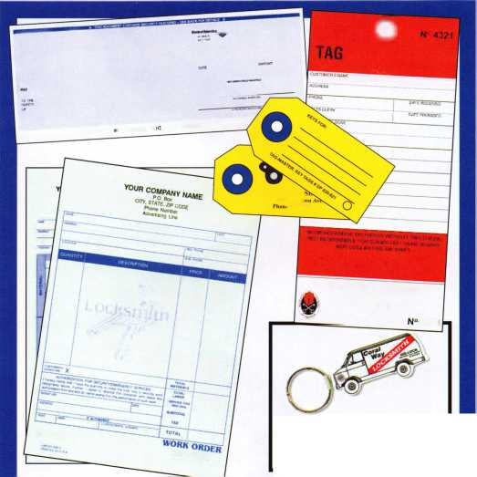

Getting Out of the Phone Loop

Making It Easy for Customers to do Business With You

By: Laurie Brown



Barbara was thrilled. She finally got a brand new auto-  
mated phone system for her business. She purchased  
the system to give her employees more time for their  
work. It seemed to her that too much of their time  
was taken up transferring calls to the "right" person  
and repeatedly giving out information about their  
hours or location. The automated system would allow  
them to become truly productive.

Sounds great, doesn't it? Wrong. It was a nightmare.  
Her customers, who were used to speaking to a human,  
now had to maneuver a difficult, confusing and some-  
times truly impossible system. Some of her customers  
dealt with the new system, but silently hated it. Some  
of them complained. Others just gave up and went  
elsewhere. The real problem was that Barbara lost track  
of what really mattered. She forgot that her customers  
were not in the way of her business-they were her busi-  
ness. In her effort to make it easier for her employees,  
she inadvertently made it more difficult for her cus-  
tomers to do business with her.

In a marketplace with so many choices, it is essential  
for you to do everything possible to make it easy for  
your customers to do business with you, any difficulty  
or obstacle that hinders or frustrates them may make  
them run away from you without you ever having a  
chance to "make things right." So what can you do to  
encourage your customers to remain your customers  
and not drive them to your competitor?

Make it easy to contact your company Have your  
phone number clearly displayed on everything: all  
printed and electronic media, receipts, your email sig-

Keynotes • November 2006

Simple to use, install, and maintain. Basic digital entry as  
simple as a single stand alone digital keypad for economical  
applications - or programmable digital keypads with access  
for hundreds of users and multiple doors and/or gates.

Complete systems that can include electric locks and  
access control devices linked to weigand control boards -  
ail manufactured by DKS.

* Durability - backed by more than

50 years of Made-in-the-USA JfP

manufacturing and expertise

* Outdoor use in all weather
* Easy to install magnetic  
  locks for both doors and  
  gates - a full line available

from 300 - 1200 lbs  
holding force

* Vandal resistant - DKS  
  keypads feature:  
  stainless steel  
  faceplates, galvanized  
  steel sub-plates, and  
  rugged steel cabinets

MODEL 1504

M HI Fmsti Button

mm TO

We use DoorKing because they have a full line of products which provides us with one-stop shopping and they have a great customer service department”

*Scott Brose, Bejan Souferian* Co-Owners, Scotland Entry Systems, Inc.

Van Nuys, California

ACCESS CONTROL SOLUTIONS

for over fifty years

**surface mount**

*mm*

**magnetic lock**

**Parking Control Gate Operator Telephone Entry**

**1504 with intercom**

**Designing and Manufacturing a full line of product since 1948**

**Locking and Entry**

**single and multi-door access control**

**flush mount**

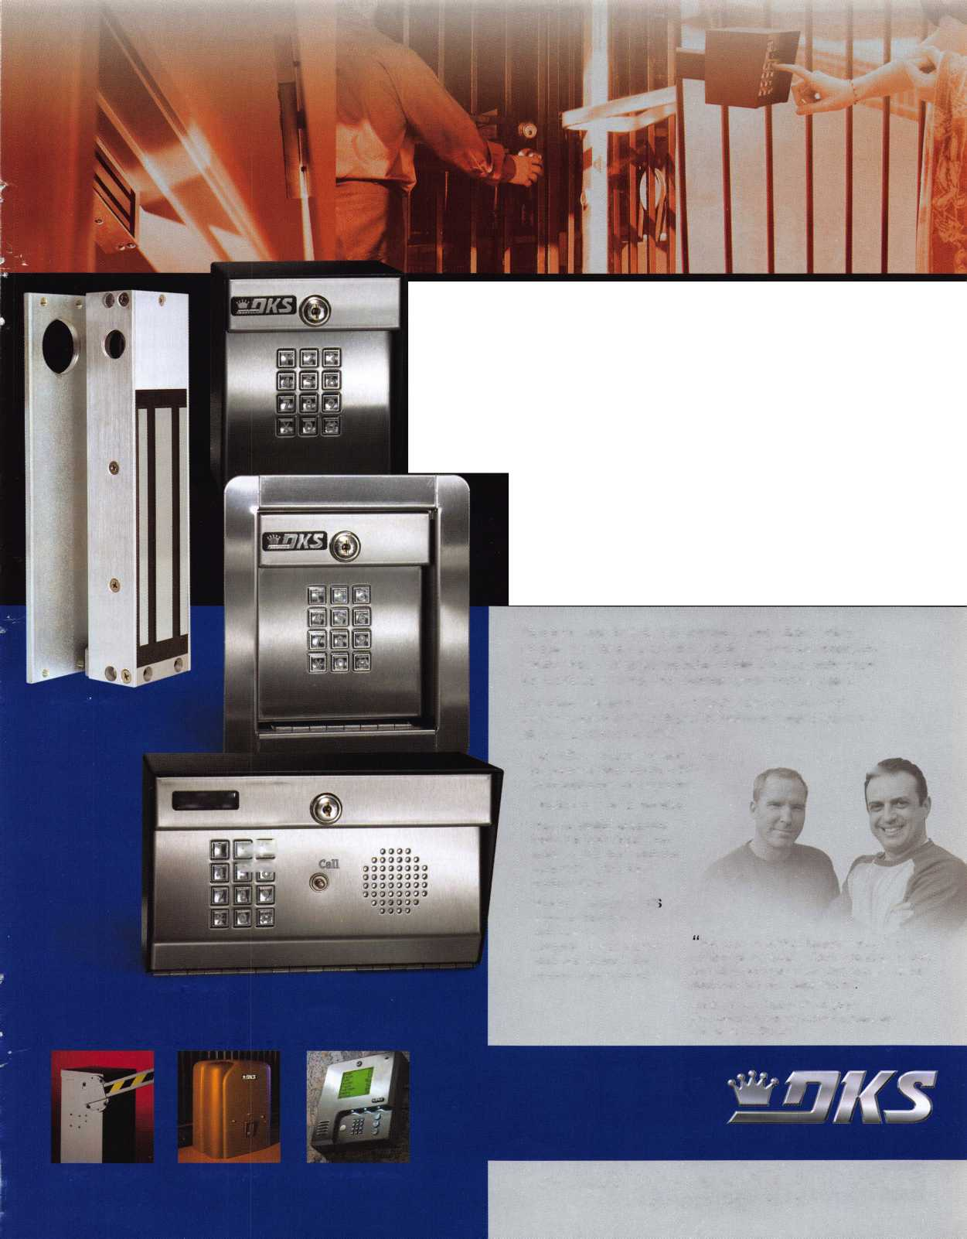

nature line, on magnets, notepads and anything else your customers may keep. List your phone information in online directories, yellow pages, etc.

Some other things that make contacting your company easy are a toll free number to make it affordable for your customers to contact you at any time, if you use phone words, include both the spelling and the numeric equivalent.

Make it easy to talk to a human. Don't make your cus­tomers search for a method to talk to a living, breathing person. If you have an automated phone system, it can be extremely frustrating and impossible to get in touch with a human being. Consider reducing the number of prompts in your system. One set of prompts is the limit for most people's patience and goodwill. If you absolutely, positively must have more than one set of prompts, make sure to offer your customers the option of speaking to an operator in the first and subsequent series of prompts.

Make it easy for your customer to reach the person they need. Have employees take ownership of every call. If they can answer a question without transferring, have them go ahead and answer. If the caller needs to talk to someone else in the company, have the person who has answered the call tell the customer that they are going to be transferred, mak­ing sure they have given the caller the correct number in the event the caller gets disconnected or "lost" in the sys­tem. If at all possible, try to get a system that allows your employees to stay on the phone with the customer until the transfer is made.

As in any other business situation, have the employee intro­duce the caller to the person they are being transferred to. The employee should provide a brief recap of the cus­tomer's needs and or questions before politely saying good­bye to the customer.

Make it easy to be on hold. 30 seconds doesn't sound so bad, does it? Phone time is different than regular time. When you are waiting for someone to help you, 30 seconds can seem like an eternity. If your people have to place a caller on hold, make sure that they check back every 30 sec­onds to update the customer and/or give them the option of being called back. Don't ask the



Keynotes • November 2006

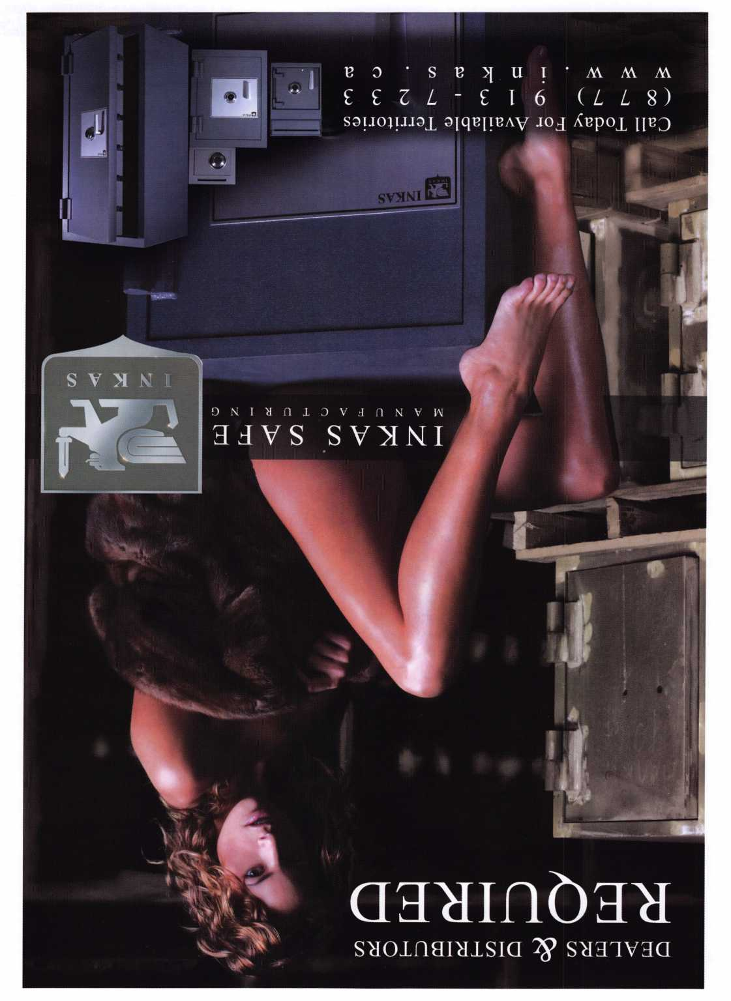

customer to call back, instead offer to call them back. Calling back your customer is a way of acknowledging that you know their time is important and you appreci­ate their patience.

If you utilize music for the on hold time, make sure that it is consistent with the image of your business. A better idea is to play information tapes that tell your customer about your business or give them some ideas to improve their life or business.

Make it easy to have a voice mail returned. If a cus­tomer leaves a voice mail message, they expect to get a call back quickly. Have your employees change their voice mail message each day. If they need to be out of the office, or if they are unable to return messages that day, their message should not only indicate that, but should also have the number or extension of a person who could be contacted immediately.

Sometimes (often) we are unaware of just how difficult and frustrating it can be to talk to a human at our own business. If you think you have an easy system, try it out yourself. Have friends and family members try it. Ask your employees to give it a try. Have them tell you what the easiest part of their experience was, as well as which parts were frustrating. Then fix the problems immediately. Make it as easy as possible for your cus­tomers to do business with you.

About the Author:

Laurie Brown is an international trainer and consultant who works to help people improve their sales, service and presentation skills. She is the author of The Teleprompter Manual, for Executives, Politicians, Broadcasters and Speakers. Laurie can be contacted through [www.thedifference.net](http://www.thedifference.net), or 1-877.999.3433, or at [lauriebrown@thedifference.net](mailto:lauriebrown@thedifference.net).



Keynotes • November 2006

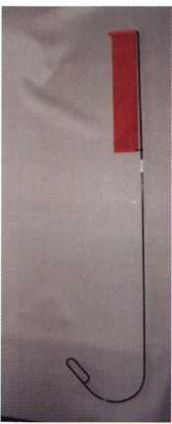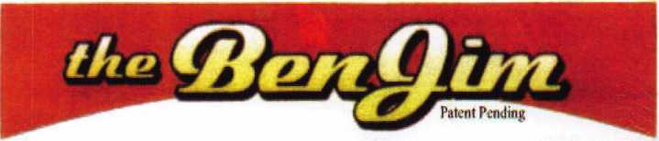

Emergency Door Opening Tools

AS SEEN AT THE 2006 A.L.O.A CONVENTION

All commercial buildings have two things in common:

* Fire code requires that all commercial locks open by a single action.
* The American Disability Act requires free access through doorways,  
  which leaves a gap between the door and the floor.

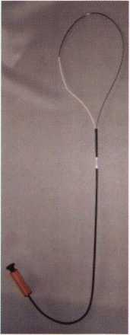

Knoblock Tool

Leverlock Tool

WITH THIS IN MIND WE HAVE DEVELOPED THE TOOLS REQUIRED TO EFFECTIVELY  
OPEN DOORS QUICKLY AND WITHOUT DAMAGE

Designed for interior commercial doors

For knoblocks, the tool is slid under the door with no cords to pull or get tangled.

For leverlocks, a similar tool is used by applying the same method of sliding the tool under the door and pull until the lever retracts.

Both tools are designed to work with very little effort, excessive force is not needed.

Visit our web site at [WWW.THEBEN-JIM.COM](http://WWW.THEBEN-JIM.COM) for more details.

THE BEN-JIM KNOBLOCK TOOL $ 99.00

THE BEN-JIM LEVERLOCK TOOL $ 79.00

SET (one each) $ 169.00

PLUS SHIPPING & HANDLING

**TO PLACE AN ORDER CALL 1-586-778-1911 OR VISIT US AT [WWW.THEBEN-JIM.COM](http://WWW.THEBEN-JIM.COM)**

MADE IN THE U.S.A BY THE BEN-JIM CORPORATION.

*

24711 Harper Ave.

St. Clair Shores * MI * 48080 * (Fax) 586-778-0530

Renegotiating With Integrity

By: Marc Freeman



Negotiating is a necessary part of life. Most of us don’t realize how often we negotiate deals and relationships. While negotiation is an essential skill, re-negotiating is far more tightly woven into the fabric of our lives. Renegotiating is the art of altering, revising, or changing a previously negotiated relationship. This relationship can be in the form of any professional or personal contract or commitment involving a written or oral promise.

If you have ever missed a deadline and must explain why you were late, you now have to renegotiate your previous commitment. How you renegotiate this will be critical. Also, how often you tend to be late will be critical in determining how you will approach this renegotiation.

But what is renegotiation? It is basically reneging on a promise or commitment. We often don’t think very highly of people who fail to keep their promises or commitments.

Nevertheless, it is possible to renegotiate with integri­ty. We can renegotiate successfully and keep our repu­tation intact — whether we’re the ones who must

break a commitment, or the ones on the receiving end of a broken commitment.

The need to renegotiate a deal does not mean the original negotiation was a failure. Most deals probably won’t remain completely satisfactory for both parties. And if the contract is a problem for one party, then it is a problem for the other. Renegotiating is an ideal response in most instances.

Before the renegotiation process can begin, we must admit that we are reneging on a promise or agreement we’ve made. This starting point will afford a valuable perspective on what we’re attempting to do when renegotiating. We shouldn’t fool ourselves into think­ing we are not breaking or changing a promise or commitment. This is why the approach is so critical.

Don’t ever try to “spin” this perspective. It won’t work, and it’s not honest. Be clear about what you’re doing when you renegotiate, and your position will be much more positively received. On the other hand, don’t feel guilty that you can’t keep your promise: guilt is a waste of time. Renegotiating is inevitable because things change. Just understand renegotiating for what



Keynotes • November 2006

• ALOA store with more

• RENEW TODAY to become eligible for great prizes including an exciting 7-day cruise!

ALOA offers you the strength of over 8,000 leading firms & individuals. ALOA is YOUR voice in the industry. ALOA represents the collective interests of the association to the press, government, and the public. ALOA is able to open many doors need­ed for your success in our ever-changing industry.

CONTACT:

Associated Locksmiths of America 3500 Easy Street Dallas, TX 75247

Phone 800-532-2562 • Fax 214-819-9736 • [www.aloa.org](http://www.aloa.org)

Take a LOOK at some of the new things  
ALOA has planned for YOU in 2007.

ALOA is excited about the new changes in-store  
for everyone in 2007. For this membership cam-  
paign we have listened to the membership and  
are rapidly making changes to suit your needs.

• Don’t miss out as we roll out our new & improved Keynotes  
magazine introducing such interactive features as a  
Q&A section exclusively for members.

• More user-friendly ALOA website.

More training & education opportunities.

Better and broader network possibilities.

books & better merchandise;

NEW products that help YOUR bottom line.

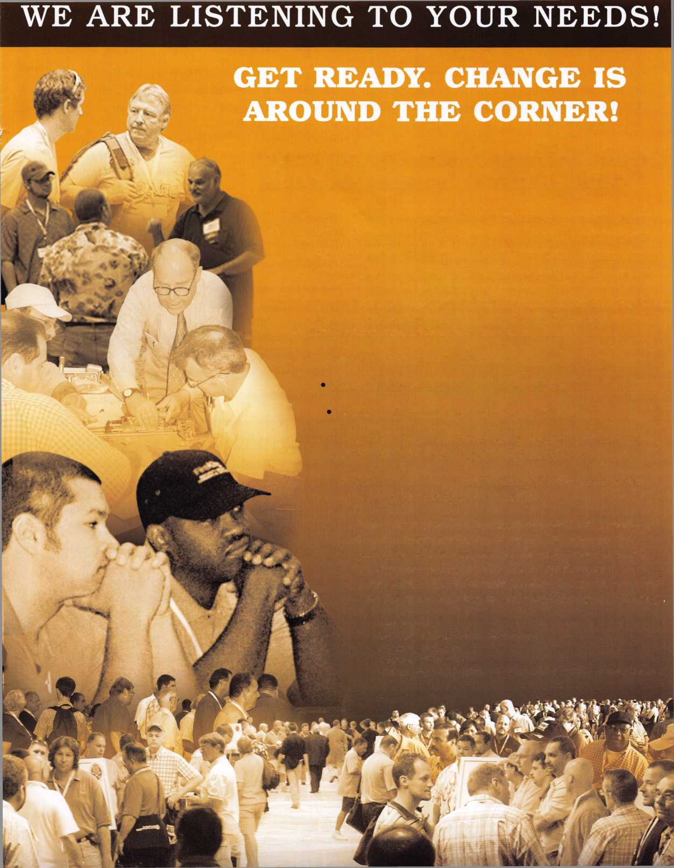

it is — an opportunity to change a relationship or agreement that is no longer working.

While the renegotiation process can be tricky, there are five principles which will greatly increase the prob­ability that all parties will walk away from the table happy with the results:

1. The Critical Path

Principle: Follow the Critical Path to renegotiate properly.

The Critical Path identifies four milestones:

The Common Ground (#1) is when both parties have committed to renegotiating. You go to your landlord because you need to break your lease because you lost your job and you cant afford the payments anymore. The landlord agrees to think about a solution. Now you can move forward because you have a Common Ground with the landlord.

The landlord offers you a discount if you can give him some assurances. Now you have created a Plausible Solution (#2).

The Comfort Zone (#3) involves working out the details of the Plausible Solution: e.g., how much rent you can afford, versus how much is the landlord will­ing to take off.

Once you’ve arrived at a Comfort Zone agreeable to both parties, you must put it in writing. This written document, once signed, is the Settlement (#4).

Deals and agreements often change dramatically during this process.

1. The Secret of the Orange Ball

Principle: Know who is in control of the Orange Bally and how to get it back**.**

We refer to the person in control as the one holding The Orange Ball. Someone has to be in control in order for the renegotiation to move foreword. If you don’t know who has the Orange Ball, it will be diffi­cult to drive the renegotiation in your direction.

Using the above example, when you go to your land­lord, he controls the Orange Ball. This is important

because if you don’t control renegotiation you can’t direct it in your direction.

The next day, the landlord tells you he’s willing to let you change the lease, but not break it. He’ll give you a break on the rent if you give him some assurances.

You explain to the landlord that you really can’t afford much and would rather just move. The landlord asks you how much you can afford. You tell him you can afford to half the current rent. Now you’ve taken back the Orange Ball.

He suggests that he accept half rent for four months, and then you would pay $200 extra each month until the discount is paid off. He has now taken back the Orange Ball.

You tell him you can’t afford an extra $200 per month, but you can handle an additional $50. You settle on an additional $75 and then you ask for six months instead of four months. The landlord agrees. You’ve controlled the Orange Ball and directed the renegotiation.

1. Hit the Refresh Button

Principle: Never overreact or act impulsively **—** take a deep breath and listen.

The Refresh Button techniques are used to get control of, and keep, the Orange Ball:

* Listen — Listening is a skill, it shows respect, and being silent and listening brings great knowledge.
* Be Nice — Being nice doesn’t mean being insipid or insincere. It means being pleasant and calm: showing understanding for the other party’s point of view, and not verbally attacking anyone.
* Use Humor — If you can laugh together then you can renegotiate almost anything. Humor is a great way to create an easier and more productive relationship.

These three techniques help set the manner in which you renegotiate. They also set a tone for how you will behave and lead the renegotiation to help both sides behave properly.

**30**

Keynotes • November 2006

1. Transcend the Details

Principle: Go beyond the details in order to stay on The Critical Path.

The solution to any renegotiation usually does not lie in the details of the transaction. It is important to not get bogged down in details that don’t help create a set­tlement. Focusing on details that don’t move the rene­gotiation forward will always impede the process.

1. Call in the Cavalry

Principle: Make sure you have the right person renego­tiating, at all times. If not. Call in the Cavalry.

It is important not to renegotiate with your ego. Bringing in a third party to renegotiate on your behalf can be critical to creating a settlement. Creating a buffer between you and the other party can help to provide a quicker settlement than trying to do every­thing yourself.

These five principles are based on the fact that every­one can learn to renegotiate successfully, and with integrity. In fact, everyone must learn to renegotiate with integrity. If we have to break our promises or commitments, let’s learn to do it right. And let’s behave properly — with insight, forethought, and compassion — when promises or commitments to us are broken. It works both ways.

About the Author:

Marc Freeman, author of the upcoming book “Renegotiating with Integrity: Its Not Business, It’s Personal,” has worked with companies all over the world, helping them to renegotiate hundreds of millions of dol­lars in contracts. A recognized expert in his field, Marc has developed a unique, practical approach to renegotiating based on the simple princi­ples of respect, honesty, creativity, and clear communications.

For more information, please contact Marc at [marc@marcfreeman.com](mailto:marc@marcfreeman.com) or at 641-472-2727.



Secure Your Future

With the Market Leader in Electronic-Locking Systems

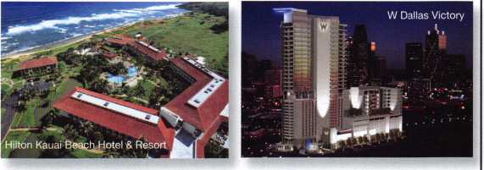

**Qualified Locksmiths  
Wanted...**

We are looking for locksmiths to contract with to install  
and service our security solutions.

Large-scale installs, steady workflow and professional  
training are some of the many benefits provided.

*Call: (800) 225-8464 Ext. 3127*

VingCard Elsafe - 631 International Parkway, Suite 100 - Richardson, TX 75081 - Toll-Free: 800.225.8464  
Phone: 972.907.2273 - Fax: 972.907.2771 - E-mail: [noram@vcegroup.com](mailto:noram@vcegroup.com) - Internet: [www.elsafe.com](http://www.elsafe.com)

An ASSA ABLOY Group company ASSSA ABLD'l

IN-STOCK...MORE SAFES

***FREE Freight Program***

*(30 States)*

AMSEC FireKing

Baidail hayman

MEIUNK yiCTOK

**turo to**

**WHOLESALE SERVICE**

800-848-9790

Keynotes • November 2006

**UNITED STATES** Statement of Ownership, Management, and Circulation

**POSTAL SERVICE\*** (Ali Periodicals Publications Except Requester Pubiications)

|  |  |  |
| --- | --- | --- |
| 1. Publication Title  Keynotes | 2. Publication Number | 3. Filing Date  10-1- ZOOG |
| 0 111 - 01°tl |
| 4. Issue Frequency  Monthly C bimonthly July /Au^.) | 5. Number of Issues Published Annually  II | 6. Annual Subscription Price  member benefit |
| 7. Complete Mailing Address of Known Office of Publication (Not printer) (Street, city, county, state, and ZIP+4®)  360o easy sfreef  Datiai nr 7sz*n | | Contact Person  Betty Souttxedctfid |
| Telephone (Include area code) |

8. Complete Mailing Address of Headquarters or General Business Office of Publisher **(Not printer)**

some



**9. FuH Names and Complete Mailing Addresses of Publisher, Editor, and Managing Editor (Do not leave Wank)**Publisher **(Name and complete mailing address)**

Same

**Editor** (Name and complete mailing address)

BeHy Southerlarvd

55**oo** easy Stirr-ct Cailas **TXTSZVI**

**Managing Editor** (Name and complete mailing address)

some

**10. Owner** (Do not leave blank. If the publication is owned by **a** corporation, give the name and address of the corporation immediately fallowed by the names and addresses of all stockholders owning or holding 1 percent or more of the total amount of stock. If not owned by a corporation, give the names and addresses of the individual owners. If owned by a partnership or other unincorporated firm, give its name and address as well as those of each individual owner. If the publication is published by a nonprofit organization, give its name and address.)

|  |  |
| --- | --- |
| Full Name | Complete Mailing Address |
| Assoo/itef LAfKcmtUv* Amort co/ | tecb easy Stared pqlloi Ttf iSZH'l |
|  |  |
|  |  |
|  |  |
|  |  |

|  |  |
| --- | --- |
| 11. Known Bondholders, Mortgagees, and Other Security Holders Owning or Holding 1 Percent or More of Total Amount of Bonds, Mortgages, or  Other Securities. If none, check box | ► □ None |
| Full Name | Complete Mailing Address |
|  |  |
|  |  |
|  |  |
|  |  |
|  |  |

**12. Tax Status** (For completion by nonprofit organizations authorized to mail at nonprofit rates) (Check one)

The purpose, function, and nonprofit status of this organization and the exempt status for federal income tax purposes:

* Has Not Changed During Preceding 12 Months
* **Has Changed During Preceding 12 Months** (Publisher must submit explanation of change with this statement)

PS Form 3$2<>, September 2006 **(Page 1 of 3 (Instructions Page 3))** PSN 7530-01-000-9931 PRIVACY NOTICE: See our privacy policy on **[www.usps.com](http://www.usps.com)**

|  |  |  |  |  |  |
| --- | --- | --- | --- | --- | --- |
| 13. Publication Title | |  |  | 14. Issue Date for Circulation Date |  |
| Kevnofe<: | | |  | September 2oob | |
| 15. Extent arid Nature of Circulation | | | | Average No. Copies Each issue During Preceding 12 Months | No. Copies of Single issue Pubttehed Nearest to Filing Date |
| a.Tc^NurnberofCof^s(Afef/»essnm; | | | | 1500 | 75 00 |
|  | (D | Mailed Outskte-County Paid Subscriptions Stated on  PS Form 3S41(fticfodepektdiaMxuMon above nominal rate, advertiser's proof copies, and exchange copies) | | UH | G2Z H |
| b. Paid Circulation (By Mail and | <2> | Mailed to-County Paid Subscriptions Stated on PS  Form 3541 (include paid distribution above nominal rate, advertiser's proof copies, and exchange copies) | | 1\ |  |
| Outsida the Mail) | (3) | Paid Distribution Outside the Mails Including Safes Through Dealers and Carriers, Street Vendors, Counter Sales, and Other Paid Distribution Outside USPS® | | 0 | 0 |
|  | (4) | Paid Distribution by Other Classes of MaB Through the USPS (e.g. First-Class Mail®) | | 0 | 0 |
| c. Total Paid Distribution (Sum of 15b (1), (2), (3), and (4)) | | | | bS5) | oaq i |
|  | <1> | Free or Nominal Rate OutektoCounty  Copies (included on PS Form 3541 | | O | 0 |
| d. Free or Nominal Rate  Distribution | <2) | Free or Nominal Rate In-County Copies Included on PS Foim 3541 | | 0 | 0 |
| (By Mail and  Outside the Mag) | (3) | Free or Nominal Rate Copies Mailed at Other  Classes Through the USPS (e.g. First-Class Mag) | | 0 | O |
| (4) | Free or Nominal Rate Distribution Outside the Mail (Canters or other means) | | “7 OO | too |
| e. Total Free or Nominal Rate Distribution (Sum of 15d (1), (2), (3) and (4) | | | | noo | <200 |
| f. Total Distribution (Sum of 15c and 15e) | | | ► | 13.5 1 | 10^1 |
| g. Copies not Distributed (See fnsfrucf/ons to PuW/sriers #4 (page #3)) | | | ► | ay.% | Mo 3 |
| h. Total (Sum of Wand g) | | | ► | I5oo | 1500 |
| rrirn rr^nnf  i rW^vtraQ  (15c divided by 15f times 100) | | | ► | ^0.35 | nnz |

16. PubBcaOon of Statement of Ownership

^jg) if the publication is a general publication, pubBcatkm of this statement is required. Wiil be printed g Publication not required.

In the **fvkh). Qfli)L&** issue of this oubfeafem.

17. Signature and Title of Editor, Publisher. Business Manager, or Owner

IO 13^)0

I oertify mat all information famished on this form is true and complete. I understand that anyone who furnishes false or misleading information on tftis form or who omits material **or** information requested on **the** form may be subject to criminal sanctions (including fines and imprisonment) and/or dvi sanctions (including dvM penalties).

PS Form 3SS6, September 2006 **(Page 2 of 3)**



T.M.

*OPERATOR SAFETY*

Injuries can be virtually eliminated. Ultra Lift does the lift­ing so that operator effort required to complete a move is minimized. Heavy loads are broken back with ease. The operator stays in control by using a combination of motor power, balance and leverage in every phase of a move.

*REDUCE LABOR COSTS*

Fewer people are required for any move with Ultra Lift. Manpower can be scheduled more productively. Labor savings often pay for the Ultra Lift in one month.

*ELIMINATE DAMAGE*

Loads are broken back, set down and moved under power with maximum leverage and operator control. Gentle handling eliminates bumps, bounces and damage to the load and premises.

*INCREASE PROFITS*

Increased operator safety, reduced labor cost and elimina­tion of damage to the load and premises all contribute to significant increases in profits.

FOR LITERATURE, VIDEO OR ON-SITE DEMONSTRATION, WRITE OR CALL:

ULTRA LIFT CORPORATION

475 STOCKTON AVENUE, UNIT E SAN JOSE, CA 95126 800-346-3057 408-287-9400 FAX 408-297-1199 E-mail: [info@ultralift.com](mailto:info@ultralift.com) [www.ultralift.com](http://www.ultralift.com)

**ULTRA LIFT** supplies the power — so you don't have to. One person can safely and easily handle loads that usually require 2 or 3 people, even up or down stairs. Two people can handle most safes to 1500 pounds. If safety is your concern, **ULTRA LIFT** is the best move you'll ever make!

U S. PATENT 4.570,953

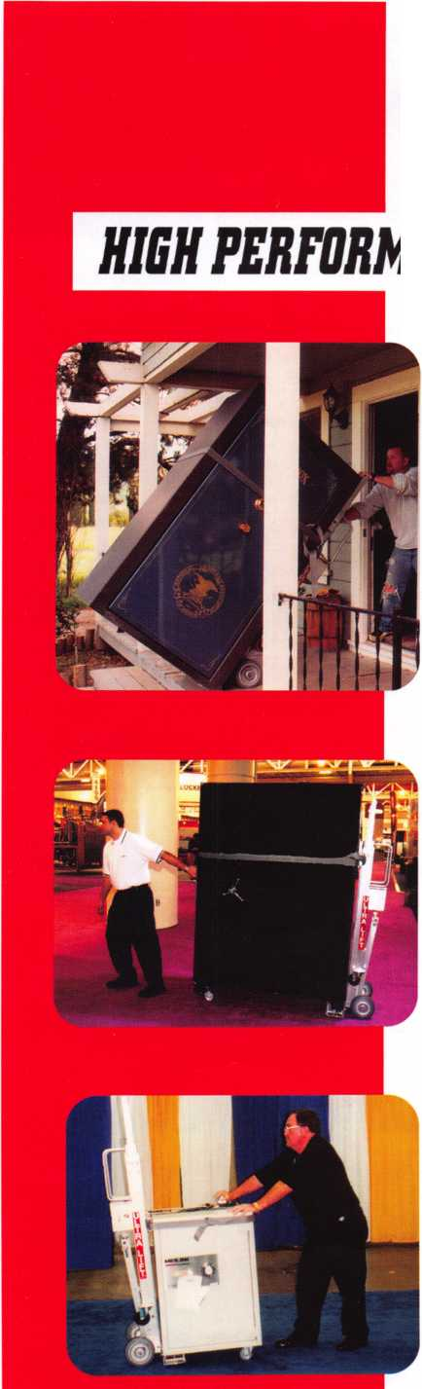

**Classifieds**

EMPLOYMENT

LOCKSMITH WANTED

Experience & hardware knowledge pre­ferred. Apprentice positions open for right individual. Excellent benefits include use of vehicle & tools, uniform, vacation and per­sonal time, health insurance, 401 (k). Background check required. Clean MVR required. Fax 303-291-01 13 or send resume & MVR to Colorado Doorways, 3333 E. 52nd Ave., Denver, CO 80216. [www.codoor.com](http://www.codoor.com), email: [hr@codoor.com](mailto:hr@codoor.com). EOE M/F/D/V

LOCKSMITH TECHNICIANS WANTED

In-house locksmith with experience road and shop work for commercial, safe and access control service. Salary plus benefits. See website or call for details. 713-755- 5906. Apply in person at 1310 Prairie, 2nd floor, Houston, Texas 77002. [www.co.harris.tx.us/hrrm/](http://www.co.harris.tx.us/hrrm/)

Employment.htm

LOCKSMITH WANTED

Locksmith wanted at Lee's Lock & Safe in Encinitas, California! Commerical, Residential, Electronic Access Control & Safes a plus. Fast paced and good bene­fits. Located in beautiful North Coastal San Diego County. In business since 1970.

Fax: 760-753-5851,

Ph: 760-753-0825.

LOCKSMITH WANTED

South King County Locksmith Company (locations in SeaTac and Federal Way) needs inside locksmiths as well as outside

technicians. Top benefits package and top pay. Medical, 401 K, paid vacation and plenty of opportunity for advancement. We will supply everything you need (tools, truck, uniform)> Please email or fax resume to: [paulbrandon@lockguys.com](mailto:paulbrandon@lockguys.com) or give me a call at 253-261-3870.

30819 Pacific Highway South Federal Way, WA 98003

LOCKSMITH WANTED

Busy shop in Woburn, Massachusetts seeks experienced Locksmith. We perform com­mercial, residential, safe, glass storefronts, card access, and automotive work includ­ing 2 AAA accounts. You don't have to know all these phases of locksmithing and we are also willing to train if interested. Sub-contractors welcome - Your van or ours. For more info please contact John at 781-933-9999 or send resume to: Locks & Keys, Inc. P.O. Box 222, Woburn, MA 01 801. Thank you for your consideration.

RELOCATE TO ALASKA

Action Security, Inc is a 44 year old securi­ty company that is interested in hiring you. It's services include electronic security, bank/credit union security; wholesale prod­ucts; hollow metal fabrication; contract hardware; retail security centers; and pro­fessional locksmith services. We have three retail locations and offer statewide services. We currently are in need of locksmiths, safe technicians, AHC's, CDC's, EHC's, electron­ic and bank technicians. Opportunity and professional growth is encouraged. Ideal candidate must be neat in appearance, people oriented, self motivated and hard working. Applicants must possess a good

driving record, pass background and drug testing. We will train the right candidate. Action offers full benefits package; competi­tive wages; medical insurance; paid vaca­tion and sick days, continuous education and profit sharing. Please email resume to: [info@actionsecurity.com](mailto:info@actionsecurity.com)

LOCKSMITH WANTED

A southern California locksmith company is looking for an honest, dependable, reliable and experienced locksmith. The company has been in business for 30 years and is looking for a locksmith to work both commericial and residential. Salary and commission, plus gen­eral insurance, paid vacation and 401K.

Fax resume to: 760-779-1811.

WANTED

Qualified locksmith with at least five years experience in shop and on the road service. Applicant must be willing to relocate to Bermuda. Knowledge and experience in opening and servicing safes, combination changing, deposit box opening and servic­ing, installations, impressions, rekey and mas­ter key commercial and residential locks, Abloy, Medeco, Everest, llco Kaba high secu­rity locks. Paid vacation, holidays, major medical insurance, pension, tools and uni­form provided. Respond to:

Fax: 1-508-366-8864 Email: [barnes-lock@ibl.com](mailto:barnes-lock@ibl.com) Barnes Locksmith Service P.O. Box HM 636 Hamilton HM CX, Bermuda

Classified Advertising Policy

Classified advertising space is provided free of charge to ALOA members and for a fee of $2.00 per word, $40.00 minimum for non members. Classified ads may be used to advertise used merchandise and overstocked items for sale, "wanted to buy" items, business opportunities, employment opportunities/positions wanted and the like. Members or non members wishing to advertise services or new merchandise for sale may purchase a Commercial Classified Ad" for a fee of $4.00 per word with a minimum of $ 100.00. Each ad will run for two issues. For blind boxes there is a $10.00 charge for members and non members. All ads must be submitted in writing to the Advertising Sales Department via fax at 817-645-7599 or through an email to [adsales@aloa.org](mailto:adsales@aloa.org) by the fifteenth of the month two months prior to issue date. ALOA reserves the right to refuse any classified adver­tisement that it deems inappropriate according to the stated purpose of the classified advertising section.

EMPLOYMENT OPPORTUNITY

Locksmith - Entry Level/Experienced - A true career opportunity in Las Vegas for enthusias­tic and dependable people! A&B Security Group is seeking entry level or experienced locksmiths to join our dynamic and growing security services organization. On the job training and advancement opportunities into many areas such as alarms, CCTV, access control systems, safes and more. Join the A&B Security Group team and receive competitive salary and excellent benefits which include: Minimum first year salary $30,000, 401K, hospitalization package, paid holidays, com­pany vehicles, even a relocation allowance! A&B Security Group is currently accepting applications from interested and qualified candidates to fill the open Locksmith posi­tions. Come work for A&B Security Group in Las Vegas and you'll stay in Las Vegas! Apply on our website [www.227lock.com](http://www.227lock.com) or call 702-227-LOCK and ask for Phil today!

WANTED TO BUY/SELL

BUSINESS FOR SALE

Mom and Pop Locksmith and Screen Business for Sale in Golden Valley,

Arizona. Located between Kingman, AZ and Laughlin, AZ in fast growing Mohave County. Health and age are our reasons for selling. Our Dodge Ram Van and Business have more than $75,000.00 in equipment and inventory. All is included. Three bedroom, two bath 24x24 detached garage (which now houses the business) on 1.7 acre lot with all utilities and no assessments owed. Make an offer that is reasonable for this area. 928-565-2294 or email at [lmburks@citlink.net](mailto:lmburks@citlink.net)

BUSINESS FOR SALE

Sacramento, California Locksmith Business with two fully equipped vans, full inventory, tools, keys and code machines, etc. Established customer base since 1976, leased store in shopping center. Contact Walter Marcotte, owner, Jeff's Locksmiths. Lie# 706234 2377 Arden Way, Sacramento California 95825.

Fax 916-929-5945 Phone 530-674-3411 Randy's Cell Phone 916-600-1557

FOR SALE

Original Curtis key blanks.

Dan Barrow 601-624-8185.

LOCKSMITH BUSINESS FOR SALE

Located in Chicago south suburban area. Shop is well established, 35 years in same location, business has many commercial/industrial accounts. Equipment and inventory are included. Owner relocat­ing will help with transition. Please call 708-424-6953.

FOR SALE - ALL ITEMS LIKE NEW!

RETIRED - PRIMUS Demo kit with lock out cylinder - $195. Everest Demo kit - $195. Schlage Finish samples - $15. Solid Oak mount 44-112 - $50. Single mount com­posite material - $25. Sold individually or $425. Takes all!!!! Contact John L. Kish. Member# 12431 Telephone 1-888-7233.

Email: [kishjohn@softhome.net](mailto:kishjohn@softhome.net)

FOR SALE

Many new and gently used Omnilock OM and OP 2000 locks. For prices and more information, please email [Omnilocksforsale@aol.com](mailto:Omnilocksforsale@aol.com) or fax 860-346-6667

BUSINESS FOR SALE

Turnkey locksmith company incorporated. All inventory and equipment, new $10,000 computerized system, domain name, phone lines & vehicles. Prime loca­tion since 1979. High foot & return client business. Loyal employees, customer base includes national retail chains. Alarm and proprietary key systems assures repeat business. Grow in a vibrant area in Seattle, Washington, where new construc­tion projects abound. Call Verlayn McManus, RE/MAX Northwest at 1-866-733-5788 or send email to [vmc- manus@remax.net](mailto:vmc-manus@remax.net).

LOCKSMITH BUSINESS FOR SALE

Growing East Tennesse locksmith business established 1987. Supports three lock­smiths with two fully equipped vans serving residential & commercial accounts as well as walk-in customers. Business located in a 1152 sq.ft, concrete building on a 7500 sq.ft, corner lot fronting main hwy. Complete set up $225,000. Call 423-586- 3101 M-F 8-5.

EQUIPMENT FOR SALE

•1 llco 009 Tubular Key Machine, 120 Volt - $200

* 1 llco Exacta Punch Setup for Kwikset 5 & 6 Pin - $200
* 1 Framan #2 Code Machine 12 Volt -

$1200

* 1 Framan Express 12 Volt - $800

All prices plus shipping. 732-773-6447 or email: [ils245@comcast.net](mailto:ils245@comcast.net)

BUSINESS FOR SALE

Storefront and mobile services established for 24 years. Located in Southeast Kentucky. We serve several counties. We are now the only locksmith company in our town. With limited competition in area. We will include 2 fully equipped vans, many contracts, systems and inventory. Good location to raise a family, retire or escape the high pressure life. We have a good growth potential. Asking $65K or best offer. Selling due to personal reasons. Contact us at [sbvbky30@hotmail.com](mailto:sbvbky30@hotmail.com). Serious inquiries only.

MOBILE BUSINESS FOR SALE IN MIAMI, FLORIDA

15 year old, well established business.

90% commercial. Very good accounts. 2000 Ford Econoline Van .75 ton, HPC 1200, HPC 9160, all pinning kits, blanks, hand tools and stock included. $190,000. Also HPC 1200 blitz, 6 months old, 30 min use, $1,000.

Call Brad 305-233-4447

35

Keynotes • November 2006

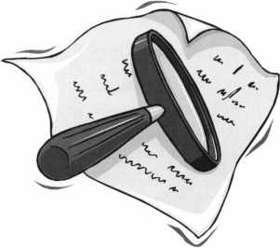

KEY CODE SERVICE

With proper ID and security clearance

we can get codes for most cars.

Fax us at 1 -800-695-6810  
or call 1-800-741-4764  
for more information.

Hello, I'm Doug Jameson of Jameson Code Services. We would like to try and make your  
business just a little easier when you make a key. We can furnish a key code to you for almost  
all cars. There is no charge should the code we provide not work. We can have most codes  
back to you within 30 minutes. Some codes are even quicker such as Ford and Toyota. We  
furnish a pin number for Chryslers, also brake codes and immobolizer codes  
for Hondas and Acuras. We have been in the key code business since 1995 and learn a little  
more everyday. We are open Monday thru Friday 8:30 a.m. to 6:00 p.m. All codes are  
$15.00. The $15.00 also includes the pin number, brake code and immobolizer code.

We would appreciate your input and welcome suggestions for improving our service. Give us  
a call at 214-630-0477 to set up your account or to have any questions answered. Looking  
forward to servicing all locksmiths. Fords and Chryslers within 15 minutes!

FYI: We are now open on Saturdays 9:00 a.m. to 1:00 p.m.

All codes are $15.00 on Saturday

We are accepting applications from ALOA Members only.

Fax us at 1-800-695-6810  
or call 1-800-741-4764

Following this brief intro­duction, is an “open letter” from the National Automotive Task Force (NASTF).ALOA has been participating in NASTF for several years. Bill Young and Ken Kupferman, both members of the ALOA Board of Directors, current­ly serve on the Vehicle Security Committee of NASTF. This committee is working to make automo­tive key codes and PINS more readily available to locksmiths. Charles Gibson, the Executive Director of ALOA, is a member of the NASTF Board of Directors.

The “open letter” briefly relates the history and pur­pose of NASTF and tells you how to participate in NASTF activities.

October 5, 2006

Open Letter to All Auto Service Organizations & Personnel Dear Colleagues:

Since November 2000 the National Automotive Service Task Force (NASTF) has made steady progress on its mission to identify and address any gaps in the availability and accessi­bility of automotive service information, tools, and training for service professionals. NASTF is a voluntary, cooperative effort which benefits everyone involved in the automo­tive service industry.

NASTF provides a single website reference ([www.nastf.org](http://www.nastf.org)) where anyone can find out how to obtain information and tools directly from OEM sources. Furthermore, NASTF provides a sin­gle forum where any service industry problem can be brought to the attention of the proper parties. Several important milestones have recently been reached.

* In July of this year, NASTF was incorporated in the District of Columbia.
* The NASTF Board of Directors has been established. It is comprised of representatives of the major stakeholders, including: Technicians, Shop owners, Security professionals, Tool companies, Training providers, Parts manufacturers and distributors, Independent information providers, Automakers
* NASTF is partnering with the National Institute for Automotive Service Excellence (ASE) to handle administration and management of the new incorporated organization.

The major activities of NASTF will continue to be handled through its standing committees: Service Information Committee Equipment & Tool Committee

Training Committee Vehicle Security Committee

The NASTF Communications Committee will continue to work with the Board of Directors and the other committees to solicit information from, and distribute information to, NASTF partici­pants and other interested parties. The Board will be considering what, if any, new committees or new priorities for existing committees are needed.

We need your help and involvement!

To get our new organization focused on the most important issues for you, you need to be involved. Here’s how:

1. Get on the NASTF distribution list. Participate in the committees.
2. Help get information to colleagues, constituents, and friends. Include NASTF information in your newsletters. Spread the word.
3. Attend the semi-annual NASTF general meetings. The next meeting is November 1, 2006 in Las Vegas.
4. Include NASTF speakers at your next membership meeting. We can provide the speakers.
5. Make suggestions. We are always looking for more promotional ideas and opportunities.

Here are some special efforts that current NASTF participants have taken.

1. Mateo Tools posted NASTF placards in all of its tool trucks nationwide.
2. CARQUEST distributed posters to shops with the CARQUEST and NASTF logos along with a list of OEM service websites.
3. Many automotive trainers distribute NASTF information to their students.
4. Associations, such as the Automotive Service Councils of California and the Automotive Service Association, distribute information routinely to their members.
5. Many organizations include a weblink to the NASTF website on their websites.
6. Many organizations acknowledge their support of NASTF on their websites or as a footer on their stationery.

To receive NASTF information, sign up for a committee, or pass along suggestions, please contact one of the following:

Mary Hutchinson, NASTF manager; phone (703) 669-6643; email [MHutchinson@ASECert.org](mailto:MHutchinson@ASECert.org) Charlie Gorman, NASTF chairman; phone (815) 943-3810; [emailcgorman@etools.org](mailto:emailcgorman@etools.org)

NASTF is a win-win for the service industry!

Sincerely,

Charlie Gorman NASTF Chairman

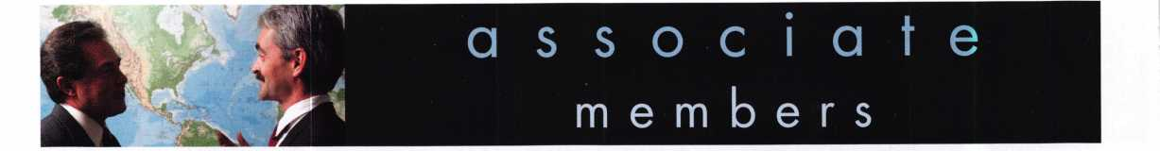

Distributor

**1st In Hardware, Inc.**

Phone: Phone: 410-646-9900 Fax: 410-646-0045 www. 1 stinhardware.com

**ADEL Fingerprint Technology, LLC**

Phone: 909-595-1222 Fax: 909-595-1667

**Accredited Lock Supply Co.**

Phone: 800-652-2835 Fax: 201-865-2435 [www.acclock.com](http://www.acclock.com)

**American Auto Lock.Com**

Phone: 717-392-6333 Fax: 717-581-8353

[www.americanautolock.com](http://www.americanautolock.com)

**Andrews Wholesale Lock Supply**

Phone: 717-272-7422 Fax: 717-274-8659 [www.andrewslock.com](http://www.andrewslock.com)

**Boyle & Chase Inc.**

Phone: 800-325-2530 Fax: 800-205-3500 [www.boyleandchase.com](http://www.boyleandchase.com)

**Clark Security Products**

Phone: 858-974-6740 Fax: 858-974-6720 [www.clarksecurity.com](http://www.clarksecurity.com)

**Cook's Building Specialties**

Phone: 505-883-5701 Fax: 505-883-5704

**Dire's Lock & Key Company**

Phone: 303-294-0176 Fax: 303-294-0198

**Direct Security Supply, Inc.**

Phone: 800-252-5757 Fax: 800-452-8600

**Discount Key Machines.Com/Busch**

Phone: 800-332-8724 Fax: 407-363-4666

**Doyle Security Products**

Phone: 800-333-6953 Fax: 612-521-0166 [www.doylesecurity.com](http://www.doylesecurity.com)

**Dugmore and Duncan, Inc.**

Phone: 888-384-6673 Fax: 888-329-3846

**E. L. Reinhardt Co., Inc.**

Phone: 800-328-131 1 Fax: 651-481-0166 [www.elreinhardt.com](http://www.elreinhardt.com)

**Ewert Wholesale Hardware**

Phone: 800-451-0200 Fax: 708-597-0881

**Foley-Belsaw Company**

Phone: 800-821-3452 Fax: 816-483-5010 [www.foley-belsaw.com](http://www.foley-belsaw.com)

**Fried Brothers Inc.**

Phone: 800-523-2924 Fax: 215-592-1255 [www.fbisecurity.com](http://www.fbisecurity.com)

**H.L. Flake Co.**

Phone: 800-231-4105 Fax: 713-926-3399 [www.hlflake.com](http://www.hlflake.com)

**Hans Johnsen Company**

Phone: 214-879-1550 Fax: 214-879-1530 [www.hjc.com](http://www.hjc.com)

**Hardware Agencies, Ltd.**

Phone: 416-462-1921 Fax: 416-462-1922 [www.hardwareagencies.com](http://www.hardwareagencies.com)

**IDN Incorporated**

Phone: 817-421-5470 Fax: 817-421-5468 [www.idn-inc.com](http://www.idn-inc.com)

**Instant Hardware Delivery, Inc**

Phone: 800-355-1107 Fax: 800-663-8518

**Intermountain Lock & Supply**

Phone: 800-453-5386 Fax: 801-485-7205 [www.intermountainlock.com](http://www.intermountainlock.com)

**International Electronics, Inc**

Phone: 800-343-9502 Fax: 617-821-4443

**Jo Van Distributors**

Phone: 416-288-6306 Fax: 416-752-8371 [www.jovanlock.com](http://www.jovanlock.com)

**L V Sales Inc**

Phone: 323-661-4746 Fax: 323-661-1314 [www.lvsales.com](http://www.lvsales.com)

**Lockmasters, Inc.**

Phone: 859-885-6041 Fax: 859-885-7093 [www.lockmasters.com](http://www.lockmasters.com)

**Locks Company**

Phone: 800-288-0801 Fax: 305-949-3619

**Locksmith Ledger International**

Phone: 847-454-2700 Fax: 847-454-2759 [www.lledger.com](http://www.lledger.com)

**McDonald Dash Locksmith Supply**

Phone: 800-238-7541 Fax: 901-366-0005 [www.mcdonalddash.com](http://www.mcdonalddash.com)

**Monaco Lock Co.**

Phone: 800-526-6094 Fax: 800-845-5625 [www.monacolock.com](http://www.monacolock.com)

**NLS Lock Supply Dba Nevada Lock S**

Phone: 702-737-0500 Fax: 702-737-7134

**Omaha Wholesale Hardware**

Phone: 800-238-4566

Fax:402-444-1664

[www.omahawh.com](http://www.omahawh.com)

**Phoenix Safe International LLC**

Phone: 765-483-0954 Fax: 765-483-0962 [www.phoenixsafeusa.com](http://www.phoenixsafeusa.com)

**Positive Identity Solutions**

Phone: 704-663-1175 Fax: 704-660-1301 [www.pids-usa.com](http://www.pids-usa.com)

**Security Distributors Inc**

Phone: 800-333-6953 Fax: 612-524-0166

**Security House**

Phone: 905-669-5300 Fax: 905-660-6313 [www.securityhouselock.com](http://www.securityhouselock.com)

**Southern Lock and Supply Co.**

Phone: 727-541-5536 Fax: 727-544-8278 [www.southernlock.com](http://www.southernlock.com)

**Stone & Berg Wholesale**

Phone: 800-225-7405 Fax: 800-535-5625

**Streetwise Security Products**

Phone: 252-830-5577 Fax: 252-830-5542

**The Locksmith Store Inc.**

Phone: 847-364-51 1 1 Fax: 847-364-5125 www. I oc ks m i th sto re. com

**Timemaster Inc.**

Phone: 859-259-1878 Fax: 859-255-0298 [www.time-master.com](http://www.time-master.com)

**Top Notch Distributors, Inc.**

Phone: 800-233-4210 Fax: 800-854-4146 [www.topnotch.bz](http://www.topnotch.bz)

**Turn 10 Wholesale**

Phone: 800-848-9790 Fax: 800-391-4553

**U.S. Lock Corp.**

Phone: 800-925-5000 Fax: 800-338-5625 [www.uslock.com](http://www.uslock.com)

**Wilson Safe Company**

Phone: 215-492-7100 Fax: 215-492-7104 [www.wilsonsafe.com](http://www.wilsonsafe.com)

Manufacturer

**A & B Safe Corporation**

Phone: 800-253-1267 Fax: 856-863-1208 [www.a-bsafecorp.com](http://www.a-bsafecorp.com)

**ABUS Lock Company**

Phone: 800-352-2287 Fax: 602-516-9934 [www.abus.com](http://www.abus.com)

**Access Security Products Ltd.**

Phone: 905-337-7874 Fax: 905-337-7873

[www.access-safe.com](http://www.access-safe.com)

**Adams Rite Mfg Company**

Phone: 800-872-3267 Fax: 800-232-7329 [www.adamsrite.com](http://www.adamsrite.com)

**Adesco Safe Mfg. Company**

Phone: 800-694-9340 Fax: 562-408-6427 [www.adesco.com](http://www.adesco.com)

**Adrian Steel Company**

Phone: 800-677-2726 Fax: 517-265-5834 [www.adriansteel.com](http://www.adriansteel.com)

**Advanced Diagnostics USA Inc**

Phone: 650-876-2020 Fax: 650-876-2022 [www.autokeys.com](http://www.autokeys.com)

**Alarm Controls Corporation**

Phone: 631-586-4220 Fax: 631-586-6500 [www.alarmcontrols.com](http://www.alarmcontrols.com)

**All Five Tool Company, Inc.**

Phone: 860-583-1691 Fax: 860-583-4516 [www.all5tool.com](http://www.all5tool.com)

**American Security Products**

Phone: 909-685-9680x2013 Fax: 909-685-9685 [www.amsecusa.com](http://www.amsecusa.com)

**BWD Lockcraft**

Phone: 973-728-3707 Fax: 973-728-3731 [www.bwdautomotive.com](http://www.bwdautomotive.com)

**Bianchi USA, Inc.**

Phone: 800-891-2118 Fax: 216-803-0202 [www.bianchi](http://www.bianchi) 1770usa.com

**Buddy Products**

Phone: 312-733-6400 Fax: 312-733-8356 [www.buddyproducts.com](http://www.buddyproducts.com)

**CCL Security Products**

Phone: 800-733-8588 Fax: 847-537-1800 [www.cclsecurity.com](http://www.cclsecurity.com)

**CompX Security Products**

Phone: 864-297-6655 Fax: 864-297-9987 [www.compxnet.com](http://www.compxnet.com)

**D&D Technologies (USA), Inc.**

Phone: 714-677-1300x292 Fax: 714-677-1299 [www.ddtechglobal.com](http://www.ddtechglobal.com)

Keynotes • November 2006

associate

members

**DETEX Corp.**

Phone: 800-729-3839 Fax: 830-620-6711 [www.detex.com](http://www.detex.com)

**Don-Jo Manufacturing, Inc.**

Phone: 978-422-3377 Fax: 978-422-3467 [www.don-jo.com](http://www.don-jo.com)

**Door Controls International**

Phone: 800-742-3634 Fax: 800-742-0410 [www.doorcontrols.com](http://www.doorcontrols.com)

**Door Jamb Armor**

Phone: 201-490-5381 Fax: 201-490-5389 [www.djarmor.com](http://www.djarmor.com)

**Doorking Inc.**

Phone: 800-826-7493 Fax: 310-641-1586 [www.doorking.com](http://www.doorking.com)

**Dorma Architectuai Hardware**

Phone: 717-336-3881 Fax: 717-336-2106 [www.dorma-usa.com](http://www.dorma-usa.com)

**E-Lock USA**

Phone: 434-589-5913 Fax: 434-589-3738 [www.e-lock-usa.com](http://www.e-lock-usa.com)

**FireKing Security Products**

Phone: 800-457-2424 Fax: 800-896-6606 [www.fkisecuritygroup.com](http://www.fkisecuritygroup.com)

**Framon Manufacturing Company Inc.**

Phone: 989-354-5623 Fax: 989-354-4238 [www.framon.com](http://www.framon.com)

**G-U Hardware Inc.**

Phone: 757-877-9020 Fax: 757-877-9720 [www.g-u.com](http://www.g-u.com)

**HPC, Inc.**

Phone: 847-671-6280 Fax: 847-671-6343 [www.hpcworld.com](http://www.hpcworld.com)

**HY-KO Products Co.**

Phone: 330-467-7446 Fax: 330-467-7442

**Hammerhead Industries, Inc.**

Phone: 805-658-9922 Fax: 805-658-8833

[www.gearkeeper.com](http://www.gearkeeper.com)

**Ingersoll Rand Security Technologies**

Phone: 317-805-5713 Fax: 317-805-5779 [www.schlagelock.com](http://www.schlagelock.com)

**Jackson Corporation**

Phone: 323-269-8111 Fax: 800-888-6855

[www.jacksonexit.com](http://www.jacksonexit.com)

**Jet Hardware Mfg., Co.**

Phone: 718-257-9600 Fax: 71 8-257-0973 [www.jetkeys.com](http://www.jetkeys.com)

**KABA ILCO Corp.**

Phone: 252-446-3321 Fax: 252-446-4702 [www.kaba-ilco.com](http://www.kaba-ilco.com)

**KEY-BAK/West Coast Chain Mfg.**

Phone: 909-923-7800 Fax: 909-923-0024 [www.keybak.com](http://www.keybak.com)

**Kenstan Lock Company**

Phone: 516-576-9090x315 Fax: 516-576-0100 [www.kenstan.com](http://www.kenstan.com)

**Keri Systems Inc.**

Phone: 408-451-2520 Fax: 408-441-0309 [www.kerisys.com](http://www.kerisys.com)

**Knaack Manufacturing Co.**

Phone: 800-456-7865 Fax: 815-459-9097 [www.weatherguard.com](http://www.weatherguard.com)

**Kustom Key Inc.**

Phone: 800-537-5397 Fax: 800-235-4728 [www.kustomkey.com](http://www.kustomkey.com)

**LAB Security**

Phone: 800-243-8242 Fax: 860-583-7838 [www.labpins.com](http://www.labpins.com)

**La Gard Inc.**

Phone: 310-325-5670 Fax: 310-325-5615 [www.lagard.com](http://www.lagard.com)

**Lock America, Inc. dba L.A.I. Group**

Phone: 714-373-2993 Fax: 714-373-2998 [www.laigroup.com](http://www.laigroup.com)

**LockPicks.Com/Brockhage Tools**

Phone: 408-437-0505 Fax: 408-516-9642

**Lucky Line Products, Inc.**

Phone: 858-549-6699 Fax: 858-549-0949 [www.luckyline.com](http://www.luckyline.com)

**M.A.G. Manufacturing**

Phone: 714-891-5100 Fax: 714-892-6845 [www.magmanufacturing.com](http://www.magmanufacturing.com)

**MUL-T-LOCK USA, Inc.**

Phone: 800-562-351 1 Fax: 973-778-4007 [www.mul-t-lockusa.com](http://www.mul-t-lockusa.com)

**Major Mfg, Inc.**

Phone: 714-772-5202 Fax: 714-772-2302 [www.majormfg.com](http://www.majormfg.com)

**Maxcess Card Systems Ltd**

Phone: 949-492-5964 Fax: 949-492-0415 [www.maxcess-card.com](http://www.maxcess-card.com)

**Medeco Security Locks**

Phone: 540-380-5000 Fax: 540-380-5010 [www.medeco.com](http://www.medeco.com)

**Mil-Comm Products Co Inc**

Phone: 201-935-8561 Fax: 201-935-6059

**Promet Safe Inc.**

Phone: 860-436-6246 Fax: 860-436-6876 [www.promet-safe.com](http://www.promet-safe.com)

**Protex Safe Co., LLC**

Phone: 818-610-8030 Fax: 818-610-8004 [www.protexsafe.com](http://www.protexsafe.com)

**ROFU International Corp.**

Phone: 253-922-1828 Fax: 253-922-7272 [www.rofu.com](http://www.rofu.com)

**Rutherford Controls Inti Co.**

Phone: 519-621-7651

Fax:519-621-7939

[www.rutherfordcontrols.com](http://www.rutherfordcontrols.com)

**STRATTEC Security Corp.**

Phone: 414-247-3333 Fax: 414-247-3564 [www.aftermarket.strattec.com](http://www.aftermarket.strattec.com)

**Sargent & Greenleaf, Inc.**

Phone: 859-885-9411 Fax: 859-885-3063 [www.sargentandgreenleaf.com](http://www.sargentandgreenleaf.com)

**Sargent Manufacturing Co.**

Phone: 800-727-5477 Fax: 888-863-5054 [www.sargentlock.com](http://www.sargentlock.com)

**Schwab Corp.**

Phone: 765-447-9470 Fax: 765-447-8278 [www.schwabcorp.com](http://www.schwabcorp.com)

**Securifort Inc**

Phone: 819-359-2226 Fax: 819-359-2218 [www.securifort.com](http://www.securifort.com)

**Securitron Magnalock Corp.**

Phone: 775-355-5625 Fax: 775-355-5636 [www.securitron.com](http://www.securitron.com)

**Security Door Controls**

Phone: 805-494-0622 Fax: 805-494-8861 [www.sdcsecurity.com](http://www.sdcsecurity.com)

**Security Solutions**

Phone: 405-376-1600 Fax: 405-376-6870

[www.securitysolutions-usa.com](http://www.securitysolutions-usa.com)

**Select Engineered Systems**

Phone: 305-823-5410 Fax: 305-823-5215 [www.selectses.com](http://www.selectses.com)

**Townsteel, Inc.**

Phone: 626-858-5080 Fax: 626-858-3393 [www.townsteel.com](http://www.townsteel.com)

**Trine Access Technology**

Phone: 718-829-2332 Fax: 718-829-6405 [www.trineonline.com](http://www.trineonline.com)

**Videx Inc.**

Phone: 541-758-0521 Fax: 541-752-5285 [www.videx.com](http://www.videx.com)

**WMW Innovation Company**

Phone: 888-474-2341 [www.sure-strike.com](http://www.sure-strike.com)

Service

Organization

**Allstate Insurance Company**

Phone: 847-551-2181 Fax: 847-551-2732 [www.allstate.com](http://www.allstate.com)

**Cardservice Mobile Solutions**

Phone: 561-210-8488 Fax: 561-953-6268 [www.cardservicems.com](http://www.cardservicems.com)

**Cross Country Automotive Services**

Phone: 800-541-2262 Fax: 781-393-0256 [www.argosi.com](http://www.argosi.com)

**HRH Insurance**

Phone: 817-462-3630 Fax: 817-462-3680 [www.hrh.com](http://www.hrh.com)

**Massglass & Door Service**

Phone: 888-742-8837 Fax: 805-497-2255 [www.massglass.com](http://www.massglass.com)

**SalesGenie.Com**

Phone: 402-593-4500 [www.salesgenie.com](http://www.salesgenie.com)

**The Mechanic Group, Inc.**

Phone: 845-735-0700 Fax: 845-735-8383 [www.mechanicgroup.com](http://www.mechanicgroup.com)

**Webster Safe & Lock Co., Inc.**

Phone: 901-332-291 1 Fax: 901-332-2878 [www.webstersinc.com](http://www.webstersinc.com)

3

Keynotes • November 2006

**3**

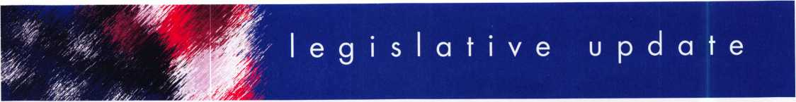

**ALOA TAKES PHONY LOCK­SMITH ISSUE STRAIGHT TO THE ATTORNYS GENERAL**

ALOA's Legislative Manager, Tim McMullen, JD, CAE was recently invited by the National Association of Attorneys General (NAAG) to make a presentation regarding phony locksmiths at their Consumer Protection meeting in New Orleans. Tim addressed the Assistant Attorneys General in charge of Consumer Protection for over 40 states and the District of Columbia.

In his presentation, Tim laid out the scam of these phony locksmith companies: how they buy 100- 250 listings in Yellow pages; give fake phone numbers and addresses to give the impression they are local companies; create fake web­sites; how a consumer calls and are given a reasonable rate for a lockout from their car or home; when the "locksmith" finishes the (usually shoddy or un-needed) work, they invoice the consumer for 3x - 15x the original amount; how these companies are set up to exclusively defraud the public and how their citizens are being ripped-off millions of dollars each year. Tim then explained how the Illinois Attorneys General office was successful in prosecuting these phony locksmiths companies.

He asked states to take action through enforcement (prosecute these phony locksmiths), education (consumer awareness campaigns),

and legislation (laws to help pro­tect legitimate locksmiths). Tim passed out a press kit to each par­ticipant that had articles, press releases and television news report transcripts which can be found at [www.aloa.org/pressroom.html](http://www.aloa.org/pressroom.html). Finally, he held out the invitation to the group that ALOA would work with them closely on this issue.

Afterwards, Tim was approached by dozens of the attendees thank­ing ALOA for putting this issue on their "radar". Most were horrified that such an organized scam could be going on in their states. The Attorney General for North Carolina (Roy Cooper), who Co- Chairs the Consumer Protection Committee told Tim he would devote one of this weekly columns to the subject. This column is picked up by every news agency in the state. Tim gave them some websites to go to and urged them to start investigating these compa­nies for themselves.

Many of the Assistant Attorneys General encouraged consumers and locksmiths to file complaints with their offices so they can start prosecuting these phony locksmith companies. You can find your state's Attorney General at [www.naag.org](http://www.naag.org). This issue must have resonated with the attendees because ALOA was invited back to address the Attorneys General at their Washington DC meeting in March 2007.

**LEGISLATION AND THE LOCKSMITH - A PERSONAL REFLECTION**

By John Brueggeman, State President, California Locksmiths Association

I was asked to write an article about my recent experiences con­cerning current California legisla­tion regarding Auto Manufacturers Supplying Automotive Key Code Information, SB 1542. This legisla­tion passed both legislative houses and was signed by the governor on September 23, 2006.

The bill was conceived and authored by the Automotive Clubs of Southern and Northern California (AAA). It was spon­sored by Senator Midgen of San Francisco and introduced on February 23, 2006. It paralleled a similar bill that had just died in the Assembly, on January 12,

2006. The major revision was moving the activation date to 2008, rather than 2007. In all, this legislative action took seven months, publicly, and will profound­ly affect the lives and livelihood of locksmiths for many years into the future.

How I got involved is that I attend­ed a state association local chapter meeting and the guest speaker mentioned that there was some California legislation concerning locksmiths being considered. The guest speaker e-mailed me the information about the bill, SB 1542. When I read it, I was

Keynotes • November 2006

immediately concerned about who was pushing (supporting) this bill and who was against it. I had recently heard about National Automotive Service Task Force (N.A.S.T.F.) and saw that this bill would reinforce their efforts.

I contacted ALOA first, and then visited the Senator's Office. There I learned about an upcoming press conference and the need to gener­ate letters of support. I attended the press conference and while I was relegated to the back, when I attended the Senate hearing I made the locksmith's presence known. (I later had an opportunity to give testimony at another Senate hearing).

I contacted the bill's authors, through ALOA's help, and sent an extensive list of concerns about the bill's language and implementa­tion. Very soon afterward, I had a conference call with the bill's author representatives and ALOA staff. It was very informative and somewhat distressing what the leg­islative staff did not know. The use of key codes and electronic signa­tures and what the locksmith need­ed to reproduce a high security automotive key were explained. Since this bill is pioneering legisla­tion for California and the nation, there are many areas that this bill did not initially addressed.

The most informative session that I had was with the auto manufactur­er's representatives and the bill's authors. Around this large square table, seventeen lawyers and three locksmiths sat. I had brought two automotive locksmith professionals, Bob Daniels and Wayde Nash, to support me with any needed auto­motive information and had anoth­

er locksmith, Craig Hackney, on phone standby. It was interesting and perplexing that the auto manu­facturers were most concerned about the integrity and ethics of the locksmith. There was also a lot of discussion about new electronic technology being introduced into newer models (migration) and manufacturer specific requirements for allowing key reproduction and duplication.

Throughout this process, I was pleased and amazed that one indi­vidual, in my capacity as State President, could affect several parts of the legislative action. I was able to offer substitute wording, existing legislative rulings & laws, real life experiences with common sense, and lobbied for the best possible key code access for lock­smiths, politically available. By working with the bill's author repre­sentatives, lawyers and advisors, California has legislatively started a process whereby the auto manu­facturers have to make available the needed access information (mechanical and electronic codes) to reproduce a key, starting January 1, 2008.

You can review the history of this bill, on the internet at <http://www.leginfo.ca.gov/pub/bi> 11/sen/sb_l 501-

1550/sb_l 542_bill_20060923_hi story.html

Editor's Note: ALOA would like to publicly thank John Brueggeman, Bob Daniels, Wayde Nash, Craig Hackney and other California lock­smiths who took hours away from their business and family to make this dream a reality - THANK YOU!! -T.M.

**THE IN'S AND OUT'S OF SB154**

On September 23, 2006, California Governor Arnold Schwarzenegger signed into law a bill (SB 1542) that establishes a statute whereby a motor vehicle owner, family member or leasee, could, through the use of a regis­tered and licensed locksmith, access the needed information from the motor vehicle manufacturers to enable the locksmith to reproduce a replacement key that would enable the vehicle owner to enter, start and operate the motor vehicle.

The auto manufacturers received many concessions and provided many compromises. The most notable exemptions to the bill have been nicknamed - "The Exotic",

"The Saab", "The BMW-model Key System", and "No RV's or Cycles" exemptions. The "Exotic Exemption" is for a manufacturer make that sold fewer than 2,500 vehicles in the prior calendar year in California. This exemption is per­manent. The "Saab Exemption" is for a motor vehicle manufacturer that sold between 2,500 and 5,000 vehicles of that line in the prior calendar year in the state, and this provision ends on January 1,2013. The "BMW-model Key System Exemption" is for a vehicle line of a motor vehicle manufactur­er that on January 1, 2006, does not provide for the reproduction of a key, by anyone other than the vehicle manufacturer itself and only itself. But these specific manufac­turers had to make a concession in this bill that the vehicle manufactur­er operate a request line 24 hours a day and seven days a week and, furnish, at a reasonable cost within one day of the request or



Keynotes • November 2006

via the next overnight delivery, a replacement key. This "BMW- model Key System Exemption" ends on January 1, 2013. The "No RV's or Motorcycles" exemp­tion is self explanatory and does not end.

The manufacturer's concessions include: making the bill, on new cars sold or leased in California, effective January 1, 2008; retain­ing and making available key code information for 25 years; making the information available 24/7/365, either directly or through a third party; that new technology, introduced after 2008, will not be exempted; and more

importantly, immunizes the manufacturer and locksmith from liability for theft of the vehicle if the statutory procedures are followed.

To make this information sharing happen, several things will have to be completed by the locksmith. In California, licensing is the law. Bonding and registering with the individual manufacturers will be required. The process for identify­ing the registered owner will be more extensive than currently required by existing law. Many of these finer procedural details have not been specifically worked out at this time. In drafting this legisla­tion, the bill's sponsors and oppo­

nents were looking at the National Automotive Service Task Force (N.A.S.T.F.) / Vehicle Security Committee work and planning for guidance on these issues.

This information is provided as a summary of the recently passed legislation. For more complete information, read the entire bill. You can also contact me through my State Website, [www.cla4u.org](http://www.cla4u.org) or [president@cla4u.org](mailto:president@cla4u.org).

John Brueggeman, State President, California Locksmiths Association

**JOIN ALOA'S LEGISLATIVE ACTION NETWORK TODAY!**

As a Legislative Action Network member, you will be "in the know" about the latest legislative happenings in your state. Each member will receive a quarterly newsletter giv­ing them the latest insight to security legislation at the state and federal levels.

It's easy to join! Just send an email to [legislative@aloa.org](mailto:legislative@aloa.org) and put"LAN" and your membership number in the subject line. We'll get you on the network right away!

If you contribute $100 or more to the Legislative Action Fund you become a member of the prestigious Legislative Action Network (LAN) Council. The Council is an impor­tant instrument in raising the standards of our profession through the legislative process by making sure that lock­smiths have the final say in how our industry will be run. As a Council member, you will receive:

• The quarterly Legislative Action Network Update alerting you to important legislation in your state and around the country (same as LAN members)

* A comprehensive guide to lobbying in your state

capital, so you can be the "voice of

ALOA" to legislators.

* A lapel pin designating you as a special ALOA LAN Council member
* Recognition in Keynotes magazine.
* Invitation to exclusive functions at the annual ALOA convention for LAN Council members.
* Complimentary Legislative Convention merchandise.

It's simple to join the LAN Council:

* Log into the ALOA Store at <http://www.aloa.org/store>
* Click on Search and type in "Council"
* From there you can join at four different donor levels
* Add this to your basket and checkout!
* Note: if this is the first time you have used the ALOA Store since December 2004, you will need to set up a username and password.

2

Keynotes • November 2006

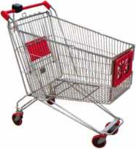

keynotes

P 1 IVCD^C

ou f Lit a

AB-2T

AB-2TT

A & B SAFE CORPORATION

114 S. Deisea Drive, Suite 3  
Glassboro, NJ 08028-6237  
856-863-1186 Fax 856-863-1208

FROM A & B SAFE CORP.

ARKETPLACE

**ekey Fingerprint  
Access Control**

**TOCAhome**

**Standalone**

**TOCAnet**

**Network**

**Weather Resistant Self-Cleaning Scanner User Friendly**

**Your Finger is the Key**

**(941)782-1227**

**[www.ekeyUSA.com](http://www.ekeyUSA.com)**



Keynotes • November 2006

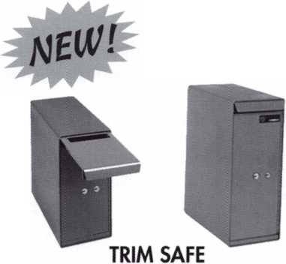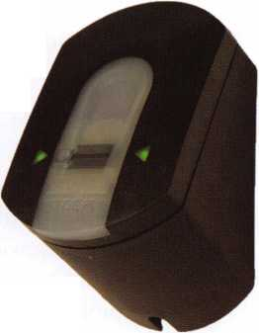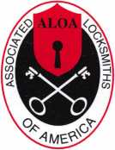

PRESS RELEASE

Date: August 28, 2006

Contact: David M. Lowell, CML, CMST  
Email: [david@aloa.org](mailto:david@aloa.org)

Phone#: 214/819-9733 xlOl

Associated Locksmiths of America speaks out on “Bump Keys”

The Associated Locksmiths of America (ALOA) says that consumers have been unduly alarmed by atten-  
tion-seeking individuals who have used the media to create a panic over recent reports of the use of  
“Bump Keys” to commit burglaries. However, because of the widespread distribution of this information  
through various media, it now has the potential to become a real security threat to consumers.

The technique of using “Bump Keys” is one of many methods used by locksmiths over the past  
75 years to open locks for which there is either a cylinder malfunction or a lost key. There are, in fact,  
many ways to prevent this method of opening so it is not a first-line technique that is used by profes-  
sional locksmiths.

Initially the individuals who promoted this information to the press may have been making what ALOA  
perceives as a misguided attempt at “consumer awareness”. They gave the impression that opening locks  
by “Key Bumping” was a wide-spread problem. It certainly has not been a method used by most burglars  
for many reasons. However, now that this method of opening some locks has become a popular theme,  
the most probable effect will be to stimulate the interest of would-be burglars to attempt to

“Bump Open” locks!

For consumers who are concerned whether their locks or premises are susceptible to this or any other  
form of burglary attack, ALOA recommends that they consult an ALOA Certified Locksmith and ask for  
recommendations for improving security. For information regarding the closest ALOA Certified

Locksmith go to [www.aloa.org](http://www.aloa.org) or call ALOA at  
800-532-2562.

The Associated Locksmiths of America (ALOA) is the world s largest organization for locksmiths and  
other physical security professionals. ALOA is dedicated to being the consumers first line of defense in  
physical security by increasing the effectiveness and productivity of locksmiths through educational pro-  
grams and materials that address broad security interests. ALOA’s activities include the ALOA  
Continuing Education (ACE) program, the ALOA Annual Convention & Security Expo and the ALOA  
Training Center, which is based in Dallas, Texas. ALOA leads the way for advanced and improved securi-  
ty performance by providing members and the security community with access to a full range of educa-  
tional programs and services.

Keynotes • November 2006

Stop giving your profit to carpenters and lumberyards!

Universal

Set

Standard

Set

**Sane time, make more money and sell better locks**

**If you don’t keep one on  
your truck, you can’t  
answer the call**

Because You Can’t Men! False Security®

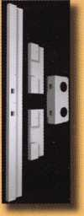

Fits doors with  
standard lock  
spacing

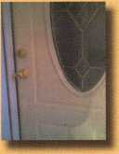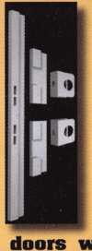

Four-piece steel system secures existing entry doors

Fix broken doorjambs and secure your hinges  
without removing the door

Gan be installed in under an hour and painted  
to match the door

Door Shield Hinge Shield

Reinforcing one point on a  
door means that others will

break whan the door is kicked.

Door lamb Armor reinforces Fits

several key weak points... non-standard

...This is a fix, not a patch lock spacing

Home security that actually works...Before intruders enter!™

**[www.djarmor.com](http://www.djarmor.com) 1-888-582-2294**

© 2G05-2006 A&G Security LLC. Aii rights reserved. Door Jamb Armor and Because You Cant Afford False Security are trademarks of A&G Security LLC.

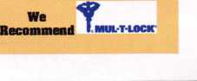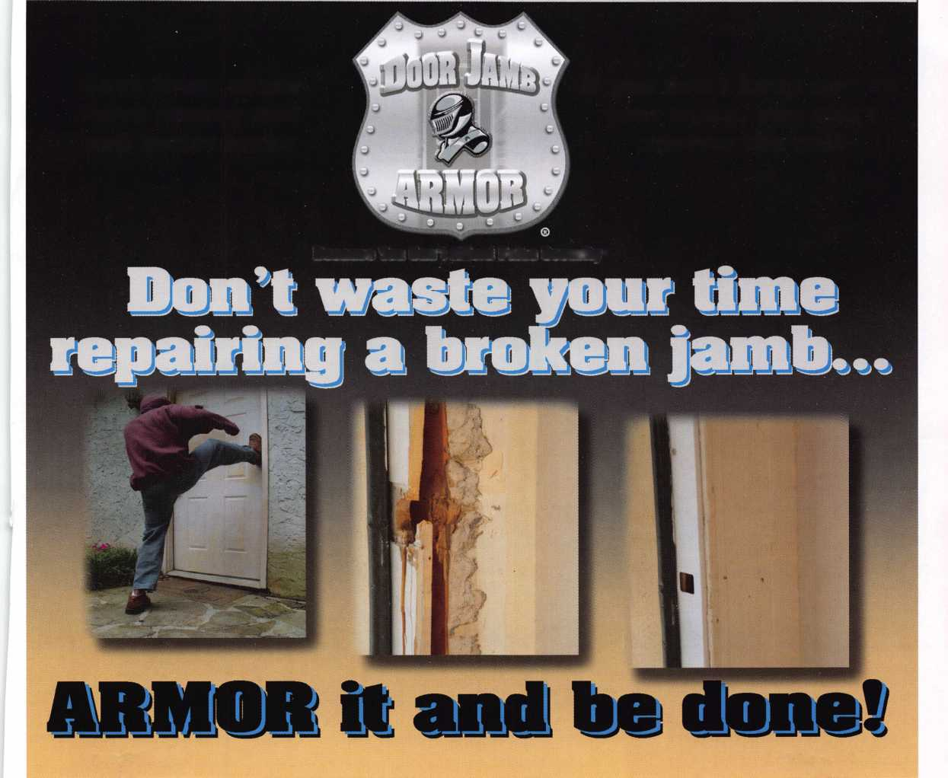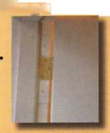

Features & Benefits

* Industrial Strength Combination Lock!
* Resists Hammer and Re-bar Attacks!
* Hardened Steel Full Metal Jacket!
* Hardened Steel Full Metal Jacket Shroud!
* Weather Resistant Black Electrocoating!
* 7/16” Chrome Plated Molybdenum Shackle!
* Inside Shackle Clearances: 1 ” and 2”!
* Shackle Pull Strength: 2,750 pounds!
* All Brass Inner Mechanism!
* Four All Brass Dials!
* 10,000 Changeable Combinations!
* Quick Delivery: Shipped from Stock!

Security Products

**A Division of The Eastern Company**

**301 West Hintz Road Wheeling, IL 60090 Telephone: 800.733.8588 Fax: 847.537.1881 [www.cclsecurity.com](http://www.cclsecurity.com)**

